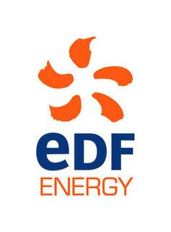

Amenity and Accessibility Fund 2018-19
Helping people enjoy and improve their local environment

Projects awarded funding 2018-19

Seven projects were awarded funding = total £22,935

Poetry People Awarded £2,050
Project Title: Growing Poems
The grant will help provide three half-day sessions of poetry workshops in a primary school in the AAF area, to create and edit new poems about the local landscape, as part of a wider project to work with eight schools across the AONB. There will be a celebration of these poems as part of the Suffolk Young Poets Competition Showcase in the autumn 2018.

Aldeburgh Food and Drink Festival CIC Awarded £2,500
Project Title: 2018 AFDF Fringe
The Festival Fringe is a great way for local businesses to engage with the main festival audience and for the public to discover the countryside that is home to our many producers and food and drink businesses. The Fringe runs for two weeks end Sept to mid October.

Beach Bonkers Awarded £4,114
Project Title: Treasuring our Beaches
To support the development of the business that holds beachcombing walks, events & workshops in east Suffolk, based around Suffolk’s signature shingle beaches to help people understand, appreciate and help to conserve this rare and fragile habitat.

Committee of Trustees for Butley Village Hall Awarded £1,771
Project Title: Village Hall Adventure Playground
To replace an aged traditional playground with free flow climbing and play equipment which will be more in keeping with the natural environment.

Suffolk Wildlife Trust Awarded £3,000
Project Title: Dingle Marshes - Frontage
The project is to undertake repairs to a special wildlife area, to reduce the effects of a breach in the shingle ridge to the north of Dunwich village.

Shingle Street Settlement Company Awarded £4,500
Project Title: Shingle Street Signage Improvement
To replace old, unsightly and irrelevant signage with improved versions to inform visitors about importance of protecting the rare flora and fauna at Shingle Street SSSI/AONB.

CS May 2018

