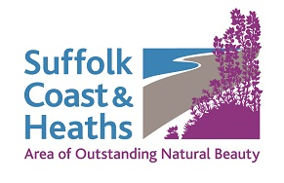
AONB Community & Conservation Fund
2018-19 projects awarded funding

Five projects were awarded funding
= total £3,060

Alton Green Residents Group, Holbrook Parish Council
Awarded £752
Project Title: Restoration at Alton Green
Reinstatement of the collapsed North Bank of Alton Green pond, placing the spoil behind a new wooden wall, and planting additional wildlife friendly plants.

Butley Ferry, part of Alde & Ore Association Awarded £600
Project Title: Walking & Cycling guide for visitors
To produce, print and circulate a leaflet promoting the historic Butley Ferry and describing circular walks and cycle routes around the Butley River and Orford area.

Suffolk Coast & Heaths AONB in partnership with Darsham Astronomical Society Awarded £516
Project Title: Dark Skies light survey
Purchase monitoring equipment. SC&H and DASH are seeking Dark Skies accreditation for parts of the AONB. The first step in achieving recognition is to conduct a light survey of the area.

Blaxhall Environment Group Awarded £752
Project Title: Maintenance and Equipment
The annual conservation management of Blaxhall Great Common/Heath requires the pulling of silver birch and scots pine saplings. By purchasing Tree Poppers and Root Saws it will make the volunteers work easier.

Neptune Sailing Awarded £544
Project title: Equipment to support training of young people
Neptune Sailing objective is to give all local primary schools a chance to experience a taster dinghy sail. As this means a mix of smaller students than in a normal course where ages vary Neptune Sailing needs to purchase 10 additional small buoyancy aids

CS May 2018

