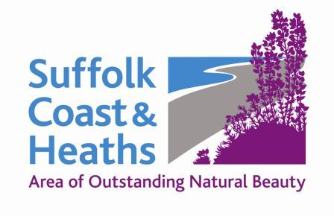
Suffolk Coast & Heaths AONB
Community & Conservation Fund

Projects awarded funding 2019-20

Six projects were supported with grants totalling £3,335

1 Aldeburgh Amazing Swifts £700
Children’s Swift Roadshow: Roadshow with primary schools within the AONB; A2 Nature Boards for permanent display, Nest boxes & sound systems, copies of ‘Storm’, installation of nest boxes x 7 schools.

2 Dunwich Greyfriars Trust £600
Signage at Greyfriars: Create, update and improve signage at Dunwich Greyfriars.

3 Bawdsey Bird Club £425
Deben Peninsula - Swift Box Project: To install 5 Swift nesting boxes on each of 4 churches around the Deben Peninsula, namely, Boyton, Shottisham, Sutton and Ramsholt.

4 Tide Mill Living Museum £700
Increasing educational visits to the Woodbridge Tide Mill: The aim of this project is to increase the number of school visits to the Woodbridge Tide Mill by offering transport subsidies to schools located within the AONB.

5 Felixstowe Ferry Golf Club £510
Buildings for Birdies: Improve habitats and bird nest sites for insects and birds.

6 Sudbourne Printmakers £400
Following Holbrook Creek: Working in print with (SEN) children from Holbrook Academy; exploring Holbrook Creek, its exit into the River Stour and its mud flats, habitats, flora and fauna.

Cathy Smith 1 May 2019

