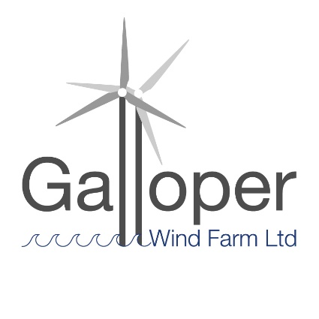
Galloper Wind Farm Fund
Projects Awarded Funding 2019-20

Seven projects were awarded grants totalling £13,220

1 Long Shop Museum CIO £2,500
History of the Garrett Family, The Works and the Social History of Leiston: A new display in the museum will be created illustrating the growth of the Richard Garrett Works and the development of Leiston into the town it is today.

2 Art Branches CIC £2,620
Coastal Art Excursions: To enable groups of young carers to access coast and participate in creative activities related to AONB conservation and management in 2 different areas.

3 Poetry People £1,850
Walking Words & Coast Lines: To create a series of video poems exploring the Suffolk Coast Path with school children from schools in the AONB area. This proposal is for sessions with Alde Valley Academy.

4 Leiston Dementia Project £1,080
Beach Boxes: To create object handling boxes about Sizewell beach and protecting the beach environment and use these in activities with people who are unable to access the beach due to their physical or mental health conditions or disability.

5 Suffolk Wildlife Trust £2,500
Where have all the eels gone? A series of workshops with100 children from year 10, exploring the natural history of eels, their historic importance in the local area and the global conservation challenges for the species.

6 Arabella Marshall £1,970
A Wing & A Prayer: A programme of activities for all people, encouraging a deeper connection with art, the natural environment and local heritage, following the installation of a glass artwork into Minsmere Sluice chapel. Minimum of eight workshops, plus talks.

7 Save Our Sandlings £700
Mapping Sizewell and Thorpeness Sandlings: Create a guide to footpaths in the vicinity of Sizewell and Thorpeness with brief explanations of significance of places to encourage people to take advantage of recreational possibilities of the area.

Cathy Smith 3 May 2019

