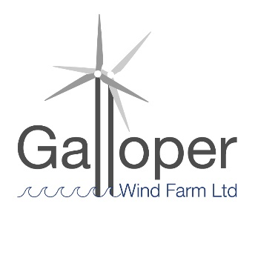
Galloper Wind Farm Fund
2020-21 projects awarded funding

Five projects were awarded £10,920

1 Art Branches CIC Awarded £2,000
Coastal Art:
To support men’s mental health in Leiston area by provision of supported creative projects allowing for and encouraging expression of self and imagination through a variety of media, such as photography.

2 Thorpeness & Aldringham Heritage Group Awarded £2,000
Heritage Visitor Hut:
After construction, landscaping and internal fit out, this stage is to erect external signage and do some internal fit out before we open the doors to visitors.

3 Suffolk Wildlife Trust Awarded £2,920
Ocean Impact Investigators:
The project aims to engage children from Leiston Primary School with their coastal environment, specifically in the context of plastic pollution and how their behaviour has an impact on nature.

4 Arabella Marshall Awarded £2,000
A Wing and a Prayer:
A programme of activities for all people, encouraging a deeper connection with art, the natural environment and local heritage, following the installation of a glass artwork into Minsmere Sluice chapel.

5 Waveney Bird Club Awarded £2,000
Minsmere Access Path: pre-commencement work
To build an access for all path from RSPB’s North Wall to East Hide. The project is managed in phases – this part of the project will support the pre-commencement work of final drawings, H&S design for build, HRA advice, careful clearance in preparation for commencement.

At 6 April 2020

