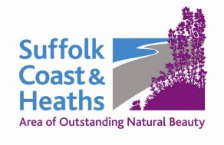
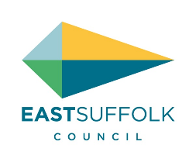

Amenity and Accessibility Fund 2020-21
Helping people enjoy and improve their local environment

A total of £18,717 (£19,653 with admin 5%) was awarded to ten projects.

1 Art Branches CIC £2,100
Coastal Art with young carers and children in care: Environmental art at various locations on Suffolk’s Coast, looking at geology, patterns and colours in the historic landscape.

2 Autism & Nature £3,132
Sounds & Music: Engaging children with autism and other special educational needs with the landscape of the Suffolk Coast & Heaths AONB and its conservation, through recording children’s voices, sounds and music.

3 National Trust £4,166
Sutton Hoo Woodland Management: To thin areas of conifer plantation and reintroduce a coppicing regime in mixed deciduous and wet woodland to create varied architectural structure and improve the woodland for wildlife.

4 Deben Peninsula CCT £2,000
Relax, Explore, Discover and Conserve the Deben Peninsula: Joint promotion of attractions, tourist industries, walks, cycle routes, history and tranquillity of the Deben Peninsula to help build the local economy in a sustainable way.

5 RSPB £2,469
Boyton Marshes anti-predator fence: To install an anti-predator fence to protect breeding wading birds, particularly avocets at our Boyton Marshes RSPB reserve from ground predators such as foxes and badgers.

6 Suffolk Punch Trust/Heritage Garden £2,500
Heritage Garden Future: To continue to maintain the garden and to convert the research into a database to be accessed by students of horticulture and other interested gardeners. This will be in digital form.

7 Waveney Bird Club £450
Minsmere Access Path: pre-commencement work: To build an access path from RSPB’s North Wall to East hide. The project is managed in phases – this application refers to outstanding works for Phase 3 and includes Habitat Risk Assessment, final drawings, construction H&S plan etc.

8 Aldeburgh Food & Drink Festival £500
Festival Fringe 2020: In a challenging climate the Fringe is a way for a diverse range of Suffolk businesses associated with food and drink to engage with the Festivals established audience. It is a great way of connecting our unique landscape with businesses that work within it.

9 Arabella Marshall £500
A Wing and a Prayer: To create and install a large glass artwork into Minsmere Chapel ruin and run a programme of activities targeting local people, primary school children and socially isolated people that encourages a deeper connection with art, the natural environment and our local heritage.

10 Gill Moon Photography £900
Suffolk Photo Walks - scavenger hunts: A project to help people explore and observe the AONB delivered through a series of free photographic scavenger hunts and a accompanying walking booklet.

List compiled 14 May 2020

