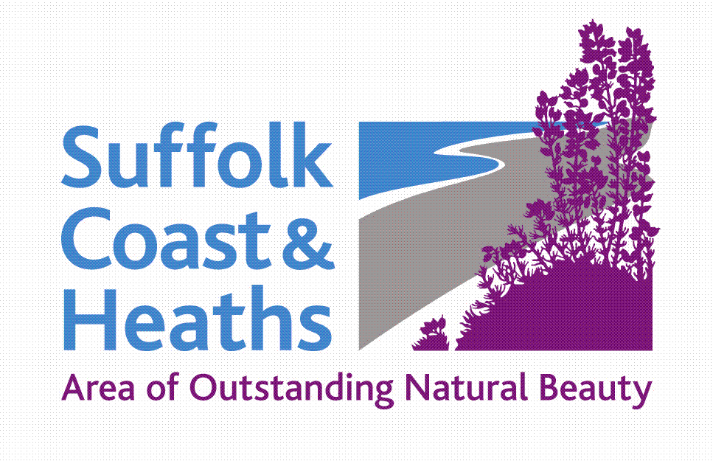
Suffolk Coast & Heaths
Area of Outstanding Natural Beauty (AONB)
Sustainable Development Fund
Projects Funded 2020-21

Eighteen Projects = £34,914

1 Art Branches CIC Awarded £2,320
Men’s Mental Health Photography along Rivers Stour and Orwell
Supported creative workshops including photography walks along the River Stour and Orwell targeting men’s mental health and suicide reduction campaign.

2 Woodbridge Riverside Trust Awarded £950
Longshed - construct an insect or bird house
Six supervised workshops in the Longshed for accompanied children (7-13) to build an insect or bird house for their garden or school.

3 Autism & Nature Awarded £2,000
Children’s voices, sounds and music
To engage with the AONB landscape and its biodiversity and conservation, for children with autism and related disabilities, including profound and multiple learning disabilities; using recordings of children’s voices, sounds made by them and natural sounds.

4 Deben Peninsula CCT Awarded £1,500
Relax, Explore, Discover and Conserve the Deben Peninsula
Joint promotion of the attractions, tourist industries, walks, cycle routes, history and tranquillity of the Deben Peninsula to help build the local economy in a sustainable way.

5 Waveney and Blyth Arts Awarded £1,200
Bugs & Blossoms
Through arts/culture and environment, using artists, poets and ecologists, at Blythburgh Churchyard we will promote, raise awareness, increase knowledge and access and help protect nature-rich habitats.

6 Gill Moon Photography Awarded £1,418
Suffolk Photo Walks - Scavenger hunts with your camera
A project to help people explore and observe the AONB delivered through a series of free photographic scavenger hunts and an accompanying walking book.

7 Woodbridge Festival of Art and Music Committee Awarded £525
Eco Zone at Festival (Forest Schools activities)
Community-run arts / music festival with strong sustainability focus. We aim to inspire creative industries and sustainability awareness. Funding for Forest School activity in the Eco Zone.

8 RSPB Awarded £2,469
Boyton Marshes anti-predator fence
To install an anti-predator fence to protect breeding wading birds, particularly avocets at our Boyton Marshes RSPB reserve from ground predators such as foxes and badgers.

9 Suffolk Wildlife Trust Awarded £4,332
Mink Monitoring
Purchase of equipment to enable volunteers to monitor mink activity on SWT’s coastal reserves, so as to reduce the impact of predation on water vole and ground nesting waders.

10 Woodbridge Tide Mill Awarded £4,000
Powering up Project
To prepare for the installation of a micro-hydrogeneration plant, with the expectation of making the Museum Carbon Neutral. To use the work as a basis for a new STEM (Science, Technology, Engineering and Mathematics)/ Sustainability learning offering.

11 Aldeburgh Food & Drink Festival Awarded £500
Festival Fringe 2020
In a challenging climate the Fringe is a way for a diverse range of Suffolk businesses associated with food and drink to engage with the Festivals established audience. It is a great way of connecting our unique landscape with businesses that work within it.

12 Deben Estuary Partnership and others Awarded £2,200
Citizen Science Coastal and Estuarine Monitoring – Fixed point photography
Erection of fixed point, mobile phone photography points as part of a citizen science project to engage the wider public in monitoring and recording change in the Deben Estuary and along the eroding coast between East Lane point and Bawdsey Manor. Ties in with AONB project.

13 National Trust Orford Ness Awarded £2,800
Wildlife Monitoring and Protection
To purchase high-resolution, waterproof thermal imager binoculars with a built-in laser rangefinder, to enable us to carry out monitoring and recording of Chinese water deer, hares and breeding birds.

14 Suffolk SketchFest (Art Safari) Awarded £,1,200
Suffolk SketchFest Events
Suffolk SketchFest is a new 3-day celebration of sketching the maritime heritage & wildlife of the River Deben in the AONB at Woodbridge with artist-led walks, demonstrations and workshops.

15 Nomad Ventures Awarded £2,500
Community Projects
To encourage engagement from the local community by kayak, three main aims: educate participants about the local area and wildlife; collect, record and dispose of refuse; complete wildlife surveys. Specifically aiming at upper-teenage.

16 Arabella Marshall Awarded £1,000
A Wing and a Prayer
To create and install a large glass artwork into Minsmere Chapel ruin and run a programmes of activities targeting local people, primary school children and socially isolated people that encourages a deeper connection with art, the natural environment and our local heritage.

17 Incredible Oceans Awarded £2,500
Siren Calling
Skills, mentoring, training and projects for young people and their communities about local environment, climate, the way we live our lives and how to make a better future for themselves and nature.

18 Waveney Bird Club Awarded £1,500
Minsmere Access Path: pre-commencement work
To build an access path from RSPB’s North Wall to East hide. The project is managed in phases – this application refers to outstanding works for Phase 3.

CS 9 April 2020

