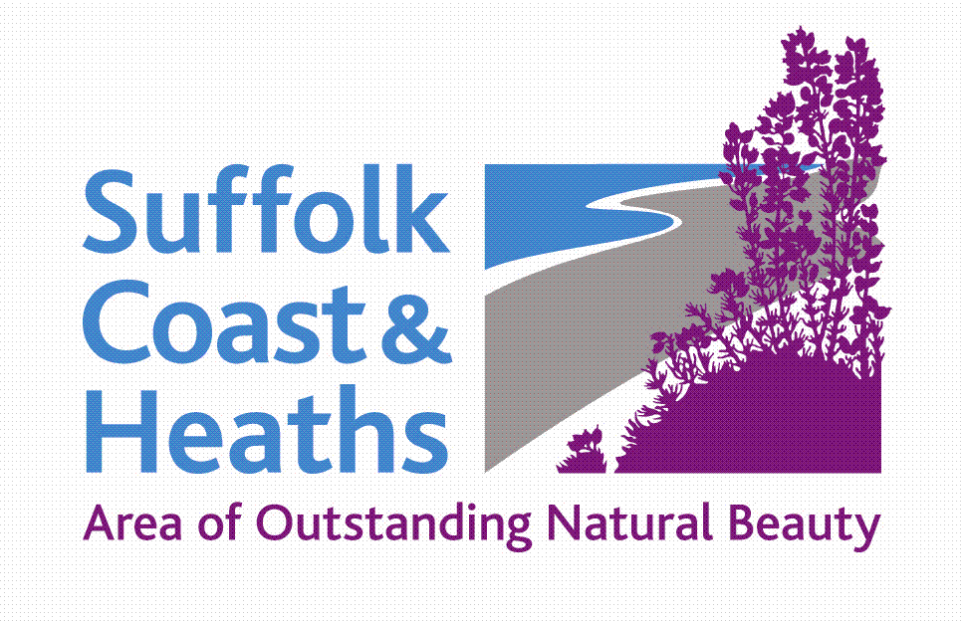
Suffolk Coast & Heaths AONB
Sustainable Development Fund

Projects Awarded Funding 2018-19
Nine projects = total £24,204

Woodbridge Riverside Trust Awarded £5,000
Project Title: Fitting out the Longshed for Community Use
The grant supports the basic fitting out of the Longshed building for use as a community facility for volunteer led projects including hands-on boat building, active learning, talks and events.

River Deben Association Awarded £2,182
Project Title: River Deben Saltmarsh Erosion Survey
The survey is to measure and record the erosion (and/or accretion) of the saltmarsh in a number of areas along the River Deben and to make proposals on how the saltmarsh can best be protected and recreated by both natural depositing of silt and active means (e.g. the use of dredgings).

Poetry People Awarded £2,050
Project Title: Growing Poems
The grant will help provide three half-day sessions of poetry workshops in a primary school in the AAF area, to create and edit new poems about the local landscape, as part of a wider project to work with eight schools across the AONB. There will be a celebration of these poems as part of the Suffolk Young Poets Competition Showcase in the autumn 2018.

Suffolk Wildlife Trust Awarded £1,462
Project Title: Church Farm Marshes waterless toilet and volunteer hub
To support the installation of a waterless toilet for staff and volunteers at Church Farm Marshes, who work across the east coast reserves.

Arabella Marshall Awarded £1,575
Project Title: Minsmere Chapel Installation - “A Wing and a Prayer” - technical design (S2)
Detailed technical designs completed for the installation of the contemporary glass art piece at Minsmere Chapel to ensure safety and endurance while maintaining environmental suitability.

Greenprint Forum (East Suffolk) Awarded £5,000
Project title: Plastic Action
An East Suffolk wide project aiming to reduce wastage of plastic and plastic litter in the natural environment as well as improving recycling. Also targeted action that will both raise awareness of the importance of and actively conserve and enhance the wildlife habitats and landscapes by removing plastic from them.

The Common Trust, Southwold Awarded £2,725
Project title: wildlife and land conservation
Conservation of wildlife habitat, enhancement of natural beauty, and promotion of sustainable tourism by restoring hedgerow, copse, reed beds and associated footpaths to the north of the Town Marshes.

Aldeburgh Food and Drink Festival CIC Awarded £2,500
Project Title: 2018 AFDF Fringe
The Festival Fringe is a great way for local businesses to engage with the main festival audience and for the public to discover the countryside that is home to our many producers and food and drink businesses. The Fringe runs for two weeks end Sept to mid October.

Shingle Street Settlement Company Awarded £710
Project title: Shingle Street vegetated shingle survey
To continue in 2018 the series of surveys of the Shingle Street vegetated shingle banks. Previous surveys were funded by HLF ‘Touching the Tide’ project. This is relevant to a range of local conservation issues.

CS May 2018 – list is in receipt order

