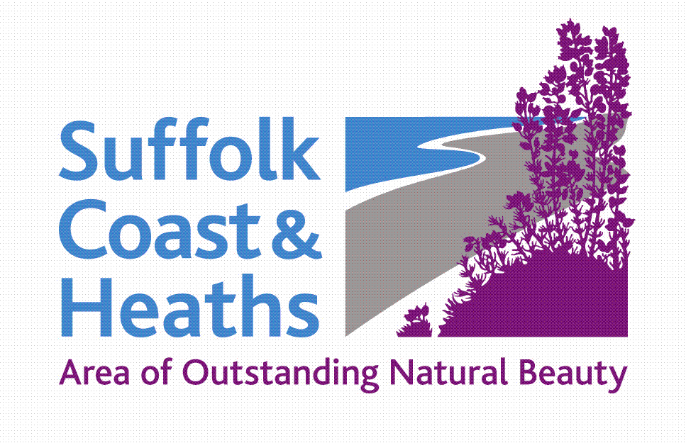
Suffolk Coast & Heaths AONB
Sustainable Development Fund

Projects Awarded Funding 2019-20

19 projects were granted funding totalling £44,420
NB the fund was oversubscribed and the panel took the decision to support all projects but often with a smaller award than requested.

1 Suffolk Marine Pioneer £1,512
‘Nature’s Value’ Photography Exhibitions: Publicly communicating the value of nature and the concept of natural capital through exhibiting winning submissions of the Marine Pioneer’s ‘Nature’s Value’ photograph competition. This supports the implementation of the Government’s 25 Year Environment Plan through the Pioneer’s ‘share lessons’ objective.

2 Art Branches CIC £2,360
Geological Layers: Exciting environmental education project looking in detail at layers of geology 2 million, 4 million and 50 million years BC on the Suffolk Coast.

3 Shotley Peninsula Shoreline CIC £1,000
Heritage Shoreline Protection Appraisal: The first part of our project requires a full and authoritative survey of the cliffs at Shotley Gate and plan of action as the current defences are coming to the end of their useful live. This will enable us to seek funding so as to carry out the aforementioned plan.

4 Field Studies Council, Flatford Mill £3,570
Environmental Engagement at KS3: To promote and improve knowledge of the habitats and wildlife that exist within Rendlesham Forest and Sutton Heath by offering (at no cost to the school or children) to 280 local school children, first-hand educational environmental experiences.

5 Suffolk Bat Group £1,000
Harp trap survey equipment: To purchase specialist bat surveying equipment (two harp traps, acoustic lures and associated equipment) to conduct long-term monitoring of bat populations.

6 Autism & Nature £2,433
Visits by special school pupils with autism and related disabilities: Visits to places of cultural and historic interest in the AONB, including Sutton Hoo and The Red House. To celebrate the children's achievements, displays of their follow-up work will be shared with peers, parents and carers, and teachers. A pdf leaflet about the outcomes of the project will be circulated to all Suffolk special schools.

7 Incredible Oceans £3,500
Siren: Events, workshops and conference for and by young people and community groups; combining art, performance and science to formulate their vision for the future of our coastal and marine environment.

8 Aldeburgh Food & Drink Festival £3,000
Fringe Festival 2019: To support the way for a diverse range of Suffolk businesses associated with food and drink to engage with the Festivals audience, and to connect the unique landscape with the business that work within it.

9 Woodbridge Riverside Trust £4,000
Going with the flow – tides and the Deben Estuary: Exhibition, information and activities in the Woodbridge Longshed about tides and tidal flow over 10 days in Autumn 2019 including expert lectures, storytelling workshops also dance workshops in schools.

10 Deben Estuary Partnership – together with Bawdsey Parish Council £2,000
Weather station and camera: Setting up a weather station and camera to monitor / cross-reference weather conditions with coastal sea conditions. Data will supplement measurements of beach erosion taken weekly by a local group. Data is watched by UCL and used by East Suffolk Council.

11 Poetry People £1,650
Walking Words & Coast Lines: To create a series of four video poems exploring the Suffolk Coast Path with school children from four schools (three primary and one upper) in the AONB area. The proposal is that the sessions with a Year 5 classes (10 year olds) at Orford Primary School and Kessingland C of E Primary School would be funded by the Sustainable Development Fund (SDF). NB funding was awarded for one school not two.

12 East Anglian Sailing School £4,000
Learning to value and respect the shore and river: To provide experiential learning to SEND children through an exciting programme of activities including keelboat sailing, environmental awareness and discovering flora and fauna in and around the AONB at Levington Lagoon on the River Orwell.

13 Arabella Marshall £1,500
Wing & A Prayer: To create and install a large glass artwork into Minsmere Chapel ruin which will launch a programmes of activities for all people, encouraging a deeper connection with art, the natural environment and our local heritage.

14 Essex & Suffolk Rivers Trust £1,000
Topsoil – Sandlings (Part 2): To trial cover crops to determine if there is a positive impact on the condition of the soil and water quality within the groundwater. We will use the results from the trial to promote cover crops to other landowners and to get additional funding to continue the work long term.

15 Greenprint Forum £3,000
Yellow Fish East Suffolk: A fuller nine-month Yellow Fish anti-pollution campaign further engaging businesses, residents and communities across East Suffolk following a 3-month small scale pilot concluded in March 2019.

16 Suffolk Coast & Heaths AONB £1,500
Improving Recreation on the Sandlings Walk: Replacement of vandalised and rotten wooden art installations with carved oak benches on the Sandlings Walk (within the AONB) to provide resting points along the 60mile route.

17 Suffolk Wildlife Trust £2,835
Capturing Wildlife Secrets: Accurate recording of wildlife by strategically placed cameras, provides vital information about population levels, habitat usage and ‘hidden secrets’ that inform decision making and best practice in site management.

18 Shotley Open Spaces £1,900
Family Activities and Walks within the AONB on the Shotley Peninsula: We would like to encourage family groups to enjoy activities and walks on the Shotley Peninsula within the AONB and learn about protecting and preserving the environment.

19 Holbrook Academy £2,660
Activity Week - Inspiring the next generation of caretakers of the AONB: An innovative inclusive project to inspire young people 11-15 living in and on the edge of the AONB to become actively involved in safeguarding the future of the AONB for their own and future generations, and to encourage them to promote this message to their local communities who are inhabitants or neighbours of the AONB.

Cathy Smith 3 May 2019

