# Suffolk Coast & Heaths AONB

## **Work Party Volunteers**

**The volunteers regularly undertake practical conservation work.**

**If you would like to work outdoors in the beautiful Suffolk Coast & Heaths,**

**help your local environment and meet some new people, then why not join us?**

**Programme for**

**October 2021 - April 2022**

**Tues 16th Nov Scrub Clearance Tunstall Common GR: TM 381565**

Clearing trees from this classic Sandlings heath and stacking and/or burning

**Tues 30th Nov Coppicing & Tree Thinning Vicarage Grove, Wenhaston GR: TM 418756**

Hand coppicing holly and where possible digging out the smaller trees

**Tues 7th Dec Scrub Clearance & Reedbed Management Melton Reedbed GR: TM 281499**

Removing bramble/Buddleia/other shrubs from the reedbed. Scything small areas to create more diverse habitat.

**Tues 14TH Dec Improve a Geological Site TBC GR: TBC**

TBC

**Tues 4th Jan Tree/Hedge Planting Dodnash Fruit Farm GR: TM 117356**

Planting trees and hedging in the newly designated area of the AONB.

**Tues 11th Jan Variety of Tasks Church Field, Waldringfield GR: TM 277445**

Removing bramble/trees from best areas for wildflowers. Dead gorse removal. Scything tall vegetation. Blackthorn reduction and removing seedling trees for re-use.

**Tues 25th Jan Erecting Shorebird Fencing Shotley Marshes GR: TM 251344**

Moving and building temporary fencing to protect foreshore for nesting birds

**Tues 8th Feb Free the Trees Bush Covert, Butley & other sites tbc GR: TM 386493**

Removing redundant tree guards, supports and matting .

**Tues 22nd Feb Scrub Clearance Tunstall Common GR: TM 381565**

Clearing trees from this classic Sandlings heath and stacking and/or burning

**Tues 8th March Improve a Geological Site TBC GR: TBC**

TBC

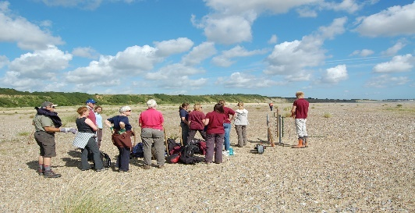

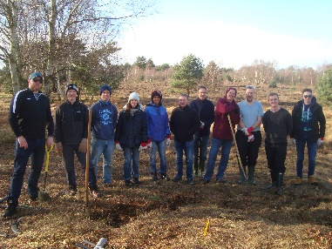 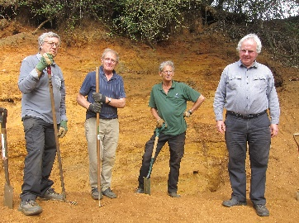

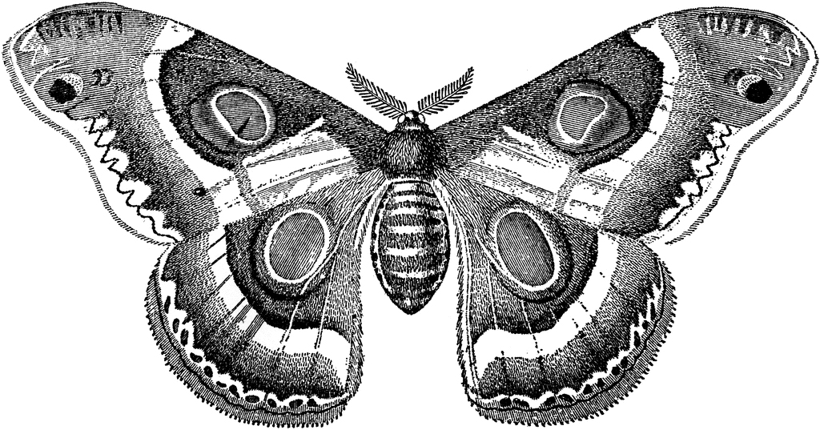 

**Most tasks start at 9.30 am and finish at 3.00 pm.**

**If times are different you will be notified.**

**You work for as long as you wish and at your own pace.**

**For further information contact**

**Neil Lister on (01394) 445218 or** [**neil****.lister@suffolk.gov.uk**](mailto:neil.lister@suffolk.gov.uk)

**Visit** [**www.suffolkcoastandheaths.org**](http://www.suffolkcoastandheaths.org)

**  ** 