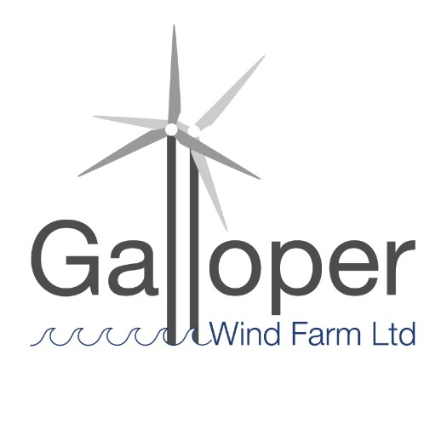
Galloper Wind Farm Fund
2022 – 2023 Application Form

Please complete all sections of the Application Form and return by end of day Wednesday 2nd March 2022
1. Name of Project

2. Name of Organisation/Group

Relevant website address

3. How much is your funding request?

4. Short Summary of Project
(Approximately 20-30 words)

5. Contact Details

MAIN CONTACT:
Name
Address/Postcode

Phone/Mobile

Email

Additional CONTACT:
Name

Phone/Mobile

Email

6. Details of Project
Please cover the range of information indicated below and keep to under two pages

- What is the overall aim(s) of the Project?
- Why is this project needed and by whom?
- Describe the work/activity you will be doing and with whom
- Who will lead the activities and who will be involved in the project (such as volunteers)?
- Is this project new, related to another project or as further work of a recent project?
- What is the planned outcome/what will be the finished project?

7. Location/Grid Reference or Address of Project:
Enclose or attach a map, plan or photo as necessary. Please note this fund is available to locations and organisations within a five-km radius of Sizewell

8. Project Timetable
Please provide estimated start and end dates, key event/activity dates
Note – the project should plan to begin from April 2022 onwards, and be completed by or before mid March 2023.

9. Name of Project Manager/Leader
Please provide details of experience/qualifications relevant to the role

10. Who/what will benefit from the project?
Who are the main targets? Will others benefit?

11. How will you measure the success of the project?
How will you know it has succeeded?

12. What Type of Organisation are you?

- A trust, charity, voluntary organisation, limited company, CIC etc, or are you an individual?

- Are you VAT registered? Yes or No

13. How does the project meet the Galloper Wind Farm Fund (GWFF) and Area of Outstanding Natural Beauty (AONB) conservation objectives
Please read the fund guidance provided before answering this section

- Does the project conserve and enhance natural beauty and maintain the special qualities of the landscape?
- Will it help manage the assets and resources of the area in a sustainable way and seek to meet environmental, economic and social needs?
- Does it support community involvement in active conservation and enhancement of the landscape?

14. Project Budget
Note: a grant can be up to 100% of costs, but the panel will be assessing the application on value for money, benefit to the environment, and demonstration of local support or need, and would therefore prefer to see an element of match funding or ‘in kind’ contributions included.

a) Total cost of the project -----------------------------

b) How much is already in place -----------------------------

c) Total outstanding amount -----------------------------

d) Amount of grant requested -----------------------------

It is important that you insert a table/spreadsheet here showing your proposed costs (income and expenditure) or attach as a page at the end of the application form. The Galloper Wind Farm Fund may support up to 100% of project costs, but it will help to include in your budget match funding or ‘in kind’ contributions in order for the Panel to be fully informed in the decision making process.

Volunteer time (‘in kind’ contributions) may be given the following values in your budget:
Volunteer contribution | Value per day  based on 7.5hr day
Unskilled | £75
Semi-Skilled | £150
Professional | £375

Below is an example of the type of table that is useful for the Panel to consider your application.

15. Additional support, budget and funding information:

- How much volunteer time may support the project?
NB this can be shown as match funding within your budget

- How will you fund the balance (if not explained above)?

- If only partial funding is available, which elements of the project would be given priority?

16. Where did you hear about this grant giving programme?

Declaration:
- I have read the Criteria and Guidance for Applicants, and accept unconditionally the Terms and Conditions
- I have authority from the organisation named in Section 2 to submit this project to the Area of Outstanding Natural Beauty (AONB) Grants Officer for a Galloper Wind Farm Fund (GWFF) grant
- I agree that the AONB may make enquiries in connection with this application to satisfy itself about relevant financial and legal matters
- I confirm that the details as set out in this application are correct to the best of my knowledge and that nothing material affecting this project has been withheld

Signed ………………………………………………….. Date …………………….

Name (please print) …………………………………………………

On behalf of …………………………………………………………

Please send your completed application form by end of day Wednesday 2nd March 2022 to:

Email AONBgrants@suffolk.gov.uk Applications sent by email are welcomed.

AONB Grants Officer
Galloper Wind Farm Fund
c/o Suffolk Coast & Heaths AONB
Dock Lane, Melton, Woodbridge, Suffolk IP12 1PE
Tel: 01394 445225

