**Suffolk Coast & Heaths Area of Outstanding Natural Beauty**

**Management Plan 2023-28**

**Contents**

**Executive Summary**

**SECTION 1: INTRODUCTION**

Forward

Infographic

Introduction

Area of Outstanding Natural Beauty management plan status

Area of Outstanding Natural Beauty purpose

Context

What is an Area of Outstanding Natural Beauty?

The Coast & Heaths Area of Outstanding Natural Beauty

Land Use Planning in the AONB

Map

Additional project areas

Relationship with the Suffolk Heritage Coast

Area of Outstanding Natural Beauty Partnership

Review of the 2018-2023 Plan

**SECTION 2: VISION FOR THE FUTURE**

The Coast and Heaths in the mid-2040s

Environmental

Social

Economic

**SECTION 3: THEMES**

Landscape

Coast and Estuaries

Nature Recovery

Land Use and Planning

Farming

Forestry and Woodland

Landscapes for All

Climate Change

Working Together

**SECTION 4: MANAGEMENT PLAN POLICIES**

**Appendices**

Maps

Data

Monitoring

Nationally Significant Infrastructure Projects

**Executive Summary**

This Management Plan provides the agreed policy for the Coast & Heaths Area of Outstanding Natural Beauty (AONB) for the period 2023-28. It describes the AONB, sets out the statutory purpose of the AONB designation and meets the duty on AONB local authorities to produce and review a Management Plan every five years.

It sets out a vision for the AONB in the mid-2040s in terms of its environmental, social and economic indicators. Through a series of themes, the Management Plan explores the opportunities and threats to delivering the statutory purpose of the AONB designation. Management Plan policies have been included to support the delivery of the vision and statutory purpose.

**SECTION 1: INTRODUCTION**

**Forward**

This Management Plan meets the requirement of the Countryside and Rights of Way Act (2000) that places a duty on local authorities to prepare and publish a plan at five years intervals.

We hope this plan goes way beyond its legal requirements. In a time of great change the aspiration for this plan is to balance the environment, social and economic needs of the area, its residents, visitors and wildlife.

The plan has been developed by a consensus of partners representing environmental, economic and social interests and has been subject to public consultation. It sets out how to deliver an area that balances the needs of the environment, business and people, a designated landscape fit for the twenty first century.

During the lifetime of the previous plan a great deal was achieved to conserve and enhance the area’s natural beauty and improve its special qualities. The AONB was extended in 2020 along the southern shore of the Stour estuary in Essex and the Freston and Samford valleys in Suffolk. Due to the extension into Essex the area is now commonly described as the Coast & Heaths AONB. Working together we can continue to make the Coast & Heaths an outstanding place to live and work in, visit and for wildlife to thrive.

National Landscapes is the new name for AONBs. This change came about from the recommendations of the Government funded Landscapes Review in 2018. The Landscapes Review Report proposed that AONBs became known as National Landscapes in common usage, although the legal name remains Area of Outstanding Natural Beauty. Given the status of this plan it was decided to largely use the legal name of the nationally designated landscape.

Cllr Andrew Reid and Nick Collinson, March 2023

Chairmen of the Coast & Heaths National Landscape Joint Advisory Committee and Partnership respectively

**Infographic**

To follow

**Introduction**

The Suffolk Coast & Heaths Area of Outstanding Natural Beauty (AONB) is known locally as the Coast & Heaths AONB. It is a nationally designated landscape that has the legal purpose to conserve and enhance natural beauty.

The informal name evolved following an extension of the AONB into Essex and further parts of Suffolk. The extension was by an Order signed by the Parliamentary Under Secretary of State, Lord Gardiner, with responsibility for AONBs on the authority of the Secretary of State, George Eustice MP, on 7 July 2020.

The legal status of the AONB requires relevant authorities such as statutory bodies and statutory undertakers, such as utility providers, to pay regard to the purpose of the AONB when taking decisions.

The Coast & Heaths AONB is one of 38 such designated landscapes in England and Wales. Most of the land in the AONB is in private or charitable ownership. AONB status brings many benefits for residents, visitors and businesses.

**Area of Outstanding Natural Beauty Management Plan status**

The purpose of the Coast & Heaths Area of Outstanding Natural Beauty (AONB) Management Plan 2023-2028 is to fulfil the statutory duty placed on local authorities to adopt and publish a plan for the AONB as outlined in Section 89 of the Countryside and Rights of Way Act (2000).

This Management Plan forms the AONB policy for local authorities in the AONB. By adopting this Management Plan, the local authorities have committed to working to deliver its objectives and have regard to the plan in the exercise of their wider responsibilities.

The Coast & Heaths AONB Management Plan 2023-2028 informs how relevant authorities will pay regard to the statutory purpose of the AONB.

Section 85 of the Countryside and Rights of Way Act (2000) states:

*In exercising or performing any functions in relation to, or so as to affect, land in an area of outstanding natural beauty, a relevant authority shall have regard to the purpose of conserving and enhancing the natural beauty of the area of outstanding natural beauty.*

Beyond the legal requirements this plan provides the framework for the co-ordination of action from partnership organisations and others whose activities impact upon the AONB.

Partnership organisations come from a wide range of interests such as wildlife, community, business, environment and access. By working together to deliver statutory AONB purpose they can further their own aims and benefit people and the environment.

The plan reflects the need for co-ordinated activity to ensure that the purposes of the AONB are met and that communities, businesses, individuals and organisations work together in a coherent manner.

The plan identifies the need to monitor changes within the AONB, be they from the delivery of the plan itself or actions outside the influence of the partnership such as climate change or the actions of others.

**Area of Outstanding Natural Beauty purpose**

An Area of Outstanding Natural Beauty (AONB) is exactly what it says it is, an outstanding landscape with distinctive character and natural beauty so precious that it is safeguarded in the national interest.

AONBs are landscapes for nature, people, business and culture.

The purpose of the AONB designation is set out in the National Parks and Access to Countryside Act (1949), it is to:

*conserve and enhance natural beauty*

Further guidance (Areas of Outstanding Natural Beauty: A Policy Statement, Countryside Commission, CCP 352, 1992) which compliments the 1949 Act notes:

*In pursuing the primary purpose of designation, account should be taken of the needs of agriculture, forestry, and other rural industries and of the economic and social needs of local communities.*

*Particular regard should be paid to promoting sustainable forms of social and economic development that in themselves conserve and enhance the environment.*

*Recreation is not an objective of designation, but the demand for recreation should be met so far as this is consistent with the conservation of natural beauty and the needs of agriculture, forestry and other uses.*

The Countryside and Rights of Way Act (2000) notes:

*Where it appears to Natural England that an area which is in England but not in a National Park is of such outstanding natural beauty that it is desirable that …. the areas [be] designated … for the purpose of conserving and enhancing the natural beauty of the area.*

**Context**

It is widely recognised that there is a climate and a biodiversity crisis. Designated landscapes such as AONBs can have a part to play in addressing the drivers of climate change and undertaking projects to slow the loss of nature. These objectives sit at the heart of this Management Plan.

This Management Plan for the Coast & Heaths Area of Outstanding Natural Beauty (AONB) is being developed during a period of change following a government review of AONBs and National Parks.

In May 2018 the government asked for an independent review into whether the protections for National Parks and AONBs are still fit for purpose. In particular, what might be done better, what changes will help and whether the definitions and systems in place are still valid.

The review’s final report was published on 21 September 2019. It was led by Julian Glover and supported by an experienced advisory group: Lord Cameron of Dillington, Jim Dixon, Sarah Mukherjee, Dame Fiona Reynolds and Jake Fiennes.

Government responded to the report on 15 January 2022. Part of the Government’s response to the report was to implement a consultation on some aspects of its response to the review that will require changes to legislation. In addition to the consultation the key elements of the government’s response include:

* A call for AONBs and National Parks to work more closely together to deliver a coherent national network of beautiful, nature-rich spaces that all parts of society can easily access and enjoy.
* Consideration of a name change for AONBs to National Landscapes with the new title encompassing new purposes. At time of writing (Aug 2022) new purposes may include a second purpose like the current National Park second purpose to promote opportunities for the understanding and enjoyment. This is designed to connect all parts of society with our protected landscapes.
* A recognition that a stronger mission for AONBs to deliver on nature recovery would deliver societal benefits. Achieved through a revised first purpose (to conserve and enhance natural beauty) to encompass this.
* Recognition of a strengthened role for AONBs in the planning system who bring substantial evidence and expertise to the process.
* An urgent need to improve opportunities and remove barriers to access for all parts of society to enjoy our nationally important, designated landscapes

Government has recognised that any new or revised statutory purpose(s) would require new legislation and that they would need to be reflected in Management Plan reviews. Given the timing of such reviews DEFRA have written to AONBs to give AONBs

*an option to delay the publication of upcoming Management Plans by up to 1 year from their original planned review date.*

The guidance, in the form of a letter from the Rt Hon Lord Benyon, Parliamentary Under Secretary of State at DEFRA with responsibility for AONBs on 7 July 2022 continues:

*In order to comply with the law without compromising the integrity of future Management Plans, Defra judges that Partnerships could simply produce a light-touch review in which they commit to produce a new Management Plan after the new guidance is published.*

*Defra has considered what a light-touch review might look like and advises the following: Partnerships would agree and publish one page of text setting out their intentions for the next Management Plan.*

Following discussion with AONB chairpersons and Local Authority funding partners it was decided not to seek a delay due to several events specific to the Coast & Heaths AONB and other opportunities and pressures facing the countryside more generally, including:

* Significant planning pressures on the AONB due to Nationally Significant Infrastructure Projects.
* Significantly increased visitor pressures.
* The development of the England Coast Path that will introduce new opportunities for enjoyment of the AONB and visitor offer.
* The new Farming in Protected Landscape progamme designed to give farmers and landowners resources to deliver AONB purpose.
* The need to address the twin concerns of climate change and wildlife loss.

The 2023-28 Coast & Heaths AONB Management Plan will represent the statutory purpose associated with AONBs at the time of writing. The AONB Partnership will consider a further review or the publication of an addendum when any new purpose(s) are known.

The AONB Management Plan should not be seen in isolation. Other national and local plans and policies influence activity in the nationally designated landscape. These include local development plans, government policy relating to agriculture and the environment and environmental non-government organisations and government agency plans.

**What is an Area of Outstanding Natural Beauty?**

An Area of Outstanding Natural Beauty (AONB) is an area that is recognised by the United Kingdom government as having national importance. This importance is reflected by its designation under the National Parks and Access to the Countryside Act (1949).

The primary purpose of the designation is to conserve and enhance natural beauty. In pursuing the primary purpose of the designation, account should be taken of the needs of agriculture, forestry and other rural industries and of the economic and social needs of local communities. Particular regard should be paid to promoting sustainable forms of social and economic development that in themselves conserve and enhance the environment.

Recreation is not an objective of the designation, but the demand for recreation should be met insofar as this is consistent with the conservation of natural beauty and the needs of agriculture, forestry and other uses.

Around 15% of England is covered by the AONB designation. There are 33 AONBs in England, 4 in Wales and one that straddles the English Welsh border and 8 in Northern Ireland. The nearest equivalent designation in Scotland are National Scenic Areas of which there are 40 covering a total of 13% of the country.

AONBs are recognised as Category V Protected Landscapes under International Union for Conservation of Nature’s (IUCN) global protected area framework, but designated under United Kingdom legislation, meaning the designation has not been impacted by United Kingdom’s departure from the European Union.

AONBs are recognised by and subject to several pieces of United Kingdom legislation and policy and local policy, including:

* National Parks and Access to Countryside Act (1949)
* Countryside and Rights of Way Act (2000)
* 25 Year Environment Plan (2018)
* National Planning Policy Framework (2021)
* Local Planning Authority Local Plans (Various)

**The Coast & Heaths Area of Outstanding Natural Beauty**

The Coast & Heaths AONB (AONB) covers an area of around 170 square miles (441 square kilometres) stretching from Kessingland, near Lowestoft, in the north, to Parkeston near Harwich on the southern shore of the Stour Estuary to the south. To the east the boundary is formed by the North Sea and the western boundary is largely to the east of the A12 and encompasses Suffolk’s estuaries.

The character of the AONB is a product of the underlying geology and its associated natural habitats. It is shaped by the effects of the sea and the interaction with people and the landscape. It is a gently rolling landscape, with the estuaries a common and dominant feature. Where the land does rise, commanding views across the landscape are rewarding.

AONBs are designated for their natural beauty. The natural beauty of AONBs is defined by 6 characteristics:

* Landscape quality
* Scenic quality
* Relative wildness
* Relative tranquillity
* Natural heritage features
* Cultural Heritage

There features are described in a document at: <https://www.suffolkcoastandheaths.org/wp-content/uploads/2021/01/Natural-Beauty-and-Special-Qualities-of-the-Suffolk-Coast-and-Heath.pdf>

Detailed assessment of the AONB landscape can be seen on the Suffolk Landscape website at [www.suffolklandscape.org.uk](http://www.suffolklandscape.org.uk) and Natural England’s National Character Area number 82 see [www.gov.uk/government/publications/national-character-area-profiles-data-for-local-decision-making/national-character-area-profiles](http://www.gov.uk/government/publications/national-character-area-profiles-data-for-local-decision-making/national-character-area-profiles).

Farmland dominates much of the AONB, interspersed with picturesque villages and the occasional small seaside town. There are forestry plantations, low lying freshwater marshes and extensive tracts of heathland. The coastal fringe is dominated by estuaries, grazing marshes and lowland heath.

Large tracts of the land are in conservation management by organisations such as the National Trust, Natural England, Essex and Suffolk Wildlife Trusts and the RSPB. These include the internationally important National Trust sites of Sutton Hoo and Orford Ness, Essex Wildlife Trust’s Wrabness reserve, Suffolk Wildlife Trust’s Hazelwood Marshes and Trimley Marshes and RSPB Minsmere. The Forestry Commission owned Tunstall and Rendlesham Forest are designated as Special Protection Areas.

There are significant proportions of the AONB that are designated as Special Areas of Conservation, Special Protection Areas and as Ramsar sites. These are shown in the Maps appendix.

There are many excellent examples of public and private land being managed in a way to deliver AONB benefit and public good. Some of this work is supported through agri-environment schemes including the Farming in Protected Landscapes programme funded by Defra.

Where the AONB joins the sea, shingle beaches often stretch for many miles. Orford Ness, the great shingle spit between Aldeburgh and Shingle Street, is the largest of its kind in Europe. In some places, soft cliffs rise behind the beach such as at Dunwich and Pakefield, demonstrating the changing and dynamic nature of the coast in this part of England.

Significant parts of the AONB coastline are not actively defended and are vulnerable to erosion and/or flooding. East Suffolk Council, working with Great Yarmouth Borough Council, North Norfolk District Council and the Broads Authority are preparing a combined Coastal Adaptation Supplementary Planning Document (SPD), which will provide guidance on the implementation of the relevant Local Plan policies.

A dominant feature of the coast are the five river estuaries. The Blyth, Alde and Ore, Deben, Orwell and Stour estuaries are the locations of some of England’s finest wildlife habitats, intertidal areas of mudflats and saltmarsh.

In some places the mouths of rivers have been blocked creating large areas of brackish or freshwater marshland, such as at Minsmere and Easton and Benacre Broads. Along many of the estuaries there are centuries-old river walls to claim or protect farmland from the sea, which now form part of the estuarine landscape.

There are areas of extensive reedbeds such as at Westwood, the UK’s largest reedbed, this is a significant landscape feature and wildlife habitat.

Much of the area was once heathland, known as the Sandlings, although there are other important heathlands. Although significant tracts remain, much of it has been fragmented, converted to farmland, planted for coniferous woodland or developed for housing or military use. Some areas of planted woodland have been designated for wildlife conservation and also provide excellent recreation opportunities.

In 2023 the AONB remains a lightly populated area that is dominated by agriculture, however, there are several large-scale industrial energy generation and transmission projects proposed which will have a significant impact on the AONB. These are part of delivering the Government’s net zero targets and targets to deliver 50GW of electricity production from offshore wind farms off the east coast.

The Suffolk Coast being identified as a site for new nuclear has raised concern and debate about the compatibility of major development and the ability to deliver the statutory purpose of the AONB designation. Balancing the national need for energy, meeting targets for net zero and safeguarding the environment within which such projects are proposed is clearly a complex matter. The lengthy consultation process has raised awareness of the AONB and brought opportunities to consider how best any adverse impacts on the AONB can be mitigated and compensated for.

In common with many other designated landscapes across the country, affordable housing stock for permanent residents is influenced by the demand for second home ownership and properties used exclusively for holiday lets. This has an influence on the social and economic characteristics of the area.

There is considerable cultural interest, with many parts of the AONB famed for their association with artists and musicians. Snape Maltings is a world class centre for the arts, Benjamin Britten, arguably the greatest composer of the 20th century, was born in Aldeburgh and founded Aldeburgh Music and the Aldeburgh Festival in the 1940s. In recent years the Latitude festival, held at Henham Park in the AONB has been entertaining thousands of people.

The built heritage within the AONB makes an important contribution to its character. There are designated built conservation areas in the AONB, including those in Aldeburgh and Southwold, that seek to protect this part of the AONB character. There are many listed buildings located throughout the AONB including lighthouses, Martello towers and sea-facing merchant houses which define the historic link between the AONB and the sea. There are also several non-designated heritage assets which are defined according to criteria adopted by the local authority.

The human influence over millennia provides a rich heritage. From internationally important archaeological sites, such as the Anglo-Saxon Sutton Hoo to military structures such as the Napoleonic Martello towers and World War structures to defend the nation from possible invasion. Other twentieth century developments at Orford Ness and Bawdsey played a significant part in international warfare, with both nuclear weapons testing and the development of radar taking place here.

**Land Use Planning in the AONB**

Local Planning Authorities are responsible for preparing Local Plans for their administrative areas. Where these fall within the Coast & Heaths Area of Outstanding Natural Beauty (AONB) the Local Planning Authorities should ensure the designation and purpose is recognised. Policy contained within Local Plans can significantly contribute to the delivery of AONB purpose.

This AONB Management Plan meets the requirement of the Countryside and Rights of Way Act (2000) section 89 duty on relevant local authorities to:

*prepare and publish a plan which formulates their policy for the management of the area of outstanding natural beauty and for the carrying out of their functions in relation to it.*

A map of the AONB showing the district councils administrative area is shown in the maps appendix.

Where Parish or Town Councils are preparing Neighbourhood Plans within, adjacent to or partially covering the AONB they should be designed to meet the obligations put on statutory bodies and statutory undertakers as required by section 85 of the Countryside and Rights of Way Act (2000).

Local Plan policies are one of the most important drivers of land use planning in AONBs. Where Local Plans are developed in AONBs they should accommodate the National Planning Policy Framework including paragraph 176 which states that:

*Great weight should be given to conserving and enhancing landscape and scenic*

*beauty in National Parks, the Broads and Areas of Outstanding Natural Beauty*

*which have the highest status of protection in relation to these issues.*

Paragraph 176 continues and notes that:

*The scale and extent of development within all these designated areas should be limited, while development within their setting should be sensitively located and designed to avoid or minimise adverse impacts on the designated areas.*

Paragraph 177 says:

*When considering applications for development within National Parks, the Broads and Areas of Outstanding Natural Beauty, permission should be refused for major development other than in exceptional circumstances, and where it can be demonstrated that the development is in the public interest. Consideration of such applications should include an assessment of:*

*a) the need for the development, including in terms of any national considerations, and the impact of permitting it, or refusing it, upon the local economy;*

*b) the cost of, and scope for, developing outside the designated area, or meeting the need for it in some other way; and*

*c) any detrimental effect on the environment, the landscape and recreational*

*opportunities, and the extent to which that could be moderated.*

Paragraph 174 notes:

*Planning policies and decisions should contribute to and enhance the natural and local environment by:*

*(d) minimising impacts on and providing net gains for biodiversity, including by establishing coherent ecological networks that are more resilient to current and future pressures;*

Development is not precluded by the AONB designation. AONBs are and should be seen as exemplars of good development, with proposals balancing the three pillars of sustainable development’s economic, environmental and social factors. Development proposals are expected to meet a higher standard of planning and design to ensure that the statutory purposes of the AONB are met.

Where proposals for development are of national importance they are determined by the relevant Secretary of State following a recommendation from the Planning Inspectorate. The process, set out in the Planning Act (2008) and subsequent reviews and revisions, was introduced to streamline the decision-making process for major infrastructure projects, with the aim to make it fairer and faster for communities and applicants alike.

This Development Consent Order process, as it is known, relates to what are known locally as the energy projects. Within the AONB several such projects are at various stages of the process. Some are under consultation; others have obtained consent or are under construction and operational. These include electricity transmission networks, offshore wind farms with associated onshore infrastructure and new nuclear electricity generation.

Some of the issues surrounding these Nationally Significant Infrastructure Projects and the AONB are explored in an appendix.

**Map**

**Additional project areas**

There are areas adjacent to the AONB that are considered important for the context of the nationally designated landscape. These areas are valued landscapes as defined by the National Planning Policy Framework and are an important part of the setting of the AONB. The Shotley peninsula, along with other areas, have been subject to a Landscape Character Assessment that identifies the links to the current AONB and the importance of a co-ordinated land management approach. These areas form what is know as an additional project area and are shown on a map in the appendices.

This Landscape Character Assessment may inform planning decisions in several ways:

* Informing policy within emerging planning documents.
* In development control where it can be used to understand the key characteristics of the landscape and its special qualities and therefore provide an evidence base from which the impacts of individual applications can be assessed, and potential mitigation considered.
* To engage the local community to support them to articulate what is special about their area and make choices about future change.

**Relationship with the Suffolk Heritage Coast**

Heritage coasts were established to conserve the best stretches of undeveloped coast in England. A heritage coast is defined by agreement between the relevant maritime local authorities and Natural England.

Heritage Coasts were established to:

* conserve, protect and enhance the natural beauty of the coastline, their terrestrial, coastal and marine flora and fauna and their heritage features.
* encourage and help the public to enjoy, understand and appreciate these areas.
* maintain and improve the health of inshore waters affecting heritage coasts and their beaches through appropriate environmental management measures.
* take account of the needs of agriculture, forestry and fishing and the economic and social needs of the small communities on these coasts.

There are no statutory requirements or powers associated with the Heritage Coast definition. However, the National Planning Policy Framework, para 178, as revised in 2021 states:

*Within areas defined as Heritage Coast (and that do not already fall within one of the designated areas mentioned in paragraph 176* [that includes AONBs] *), planning policies and decisions should be consistent with the special character of the area and the importance of its conservation. Major development within a Heritage Coast is unlikely to be appropriate, unless it is compatible with its special character.*

The Heritage Coast purpose includes objectives for conserving the environmental health and biodiversity of inshore waters and beaches, and to extend opportunities for recreational education, sporting and tourist activities that draw on, and are consistent with, the conservation of their heritage features.

The Suffolk Heritage Coast was defined in 1973 and is largely contained within the AONB, although the defined area runs 3km out to sea, parallel with the eastern AONB boundary. It runs from Kessingland to Felixstowe and incorporates the Blyth, Alde and Ore and lower Deben estuaries.

**Area of Outstanding Natural Beauty Partnership**

In 1993 the Suffolk Coast & Heaths AONB Partnership was formed. This is made up of organisations with an interest in AONB. Membership of the Partnership evolves over time but includes representatives from local authorities; businesses; environmental organisations; farming bodies; government agencies; community bodies and tourism industries.

The AONB Partnership work together to deliver the purpose of the AONB designation which in turn reflects individual organisational objectives.

A list of AONB Partnership members is given in appendix XX

The AONB staff team, funded by DEFRA and local authorities and hosted by Suffolk County Council, provides the secretariat for the AONB Partnership.

**Review of the 2018-2023 Plan**

The 2018-2023 AONB Management Plan was the third version of the document since the Countryside & Rights of Way Act 2000 placed a duty on local authorities to produce and review such documents.

The 2018-23 plan contained 33 objectives. Of these, 31 of the 33 have been assessed as being at least in part delivered, a fulfilment rate of 94%. Notable partnership working successes from the last plan include:

* Delivery of the Suffolk Marine Pioneer Project
* Securing funding of over £1mn to deliver low voltage power cable undergrounding project via Ofgem scheme
* Secured funding of over £259,000 to deliver landscape enhancement projects via the Landscape Enhancement Initiative Ofgem scheme.
* Secured £140,000 funding from National Lottery Heritage Fund to deliver awareness and engagement projects
* Distributed over £80,000 per year through AONB grants funded by section 106 agreements and DEFRA, supporting over 200 individuals, societies and businesses
* Facilitated over 200 volunteer days per year in non-Covid impacted years
* Supported more than 20 Beachwatch events each year (even during Pandemic restrictions), involving over 1,000 community volunteers
* Worked with partners to act as advocate for AONB in Nationally Significant Infrastructure Project hearings and consultations for proposals such as

Sizewell C and offshore wind farm proposals

* Worked in partnership to act as an advocate for the AONB to inform local planning authorities on AONB issues
* Worked with partners, including Natural England, to deliver boundary extension for the Suffolk Coast & Heaths AONB
* Partnership working to inform Designated Landscapes Review
* Secured copy and advertising revenue for annual AONB newspapers and distributed 25,000 copies each year
* Delivered a planning event with partners that attracted 170 delegates
* Facilitated, with partners, a national AONB conference
* Worked in partnership to raise awareness of AONB during fiftieth anniversary celebrations
* Worked with partners to support delivery of Suffolk Walking Festival
* Partnership working to publish State of AONB report
* Published Guide on Use of Colour in Development that was developed with partners to guide development in AONB
* Published annual Volume and Vale study of tourism in AONB
* Supported community activity for projects delivering AONB purpose
* Delivering a Farming in Protected Landscapes programme – building relations with landowners and investing over £100,000 in farmer-led projects for climate, nature, people and place
* Engaged in 6 nationally Significant Infrastructure project consultations and over 100 Town and Country Planning Act applications

While there were many successes during the period of 2018-23, the period covered a period of significant challenge. This included a number of Nationally Significant Infrastructure Project proposals that are likely to have an impact on the AONB. The Covid pandemic carried with it a significant amount of recreational pressures at specific locations.

**SECTION 2: VISION FOR THE FUTURE**

**The Coast and Heaths in the mid-2040s**

The 20+ year vision builds on the aspirations and delivery of previous AONB Management Plans. It has been divided into two sections; a summary of the vision and consideration of how environmental, social; and economic aspects can support the delivery of the summary vision.

The summary vision stems from the primary purpose of the AONB designation to conserve and enhance natural beauty. The objectives contained in this Management Plan seek to deliver that vision.

The summary vision:

*The Coast & Heaths AONB is recognised as a special place by residents and visitors alike for its landscapes, wildlife and heritage. The impacts of climate change are being mitigated and adaptation is the norm. It is contributing to wildlife recovery and provides opportunities for all sections of society to recharge and improve their physical and mental health. The farming sector is thriving and is supported to deliver projects for the public good, the tourism sector is trading on the backdrop of an outstanding landscape. Nationally significant energy projects seek to avoid harm to the area’s natural beauty and contribute to delivering the AONB purpose.*

**Environmental Vision**

By the mid-2040s the Coast & Heaths Area of Outstanding Natural Beauty (AONB) landscape is at the forefront of adapting to the impacts of climate change, particularly on the coast, mitigating many of the impacts being felt and addressing the causes of climate change at an AONB level.

Decisions relating to development will recognise the benefit of long term planning to consider immediate and future impacts on the reasons for the AONB designation and purpose.

Landscapes rich in wildlife that are conserved and enhanced contribute to wildlife recovery and human wellbeing. Individual features, including individual species and habitats, are thriving and their management is supported through well-resourced public and private mechanisms including Biodiversity Net Gain. Biodiversity Net Gain is a government strategy to develop land and contribute to the recovery of nature. It is a way of making sure that habitat for wildlife is in a better state than it was before development took place.

Sustainable transport opportunities and infrastructure will be enhanced to reduce the environmental impact of travel. Walking, cycling and public transport will be the norm and where individual transportation is undertaken more sustainable fuels are used backed up by suitable infrastructure.

Where nationally significant infrastructure projects have been developed in the AONB or its setting, the unavoidable negative impacts have been minimised, mitigated and compensated for in so far as Development Consent Orders require.

Features that make up the defined natural beauty of the AONB, such as landscape quality, scenic quality, relative wildness, relative tranquillity, natural heritage features and cultural heritage are conserved and enhanced.

Wildlife is recovering and the resources to maintain species numbers are available.

**Social Vision**

By the mid-2040s the residents of and visitors to the Coast & Heaths Area of Outstanding Natural Beauty (AONB) will have a deep appreciation, understanding and respect of the area’s nature, natural beauty and designation.

Barriers to enjoyment and access to the AONB, such as awareness of opportunity and access to transport are recognised and removed where possible. All parts of society can enjoy the nationally important, designated landscape and enjoy it in a way that does not detract from its natural beauty.

Local communities have an important role and a mechanism to influence decision making on topics that effect their quality of life and local environment through engagement in planning processes and improving their understanding of what makes the nationally designated landscape special.

Communities recognise the significance of the nationally designated landscape they live in and the importance of sharing the benefits of the AONB to visitors who contribute to the viability of many local businesses. Visitors recognise and act upon their responsibilities to residents and the environment.

There are a range of opportunities for people to get actively involved in caring for their landscape. The challenge of sustainable living and carbon emission reduction has been embraced by communities and local businesses. There is support for people affected by the impacts of climate change and plans in place to support adaptation.

There are a range of opportunities for people to access the landscape and benefit from the advantages that it brings. The impacts of greater access are mitigated by increased understanding of activity that can have a negative impact on area. The Recreational Disturbance Avoidance Mitigation Strategies in Essex and Suffolk are used to offset negative impacts and support engagement and understanding.

The England Coast Path is an important part of access to the AONB bringing health benefits and providing economic opportunities.

**Economic Vision**

By the mid-2040s the Coast & Heaths Area of Outstanding Natural Beauty (AONB) has new and established enterprises that are thriving and contributing to AONB purpose.

Within a broad-based local economy, sustainable tourism is widespread and tourism businesses are increasingly involved in careful stewardship of the area. Local food and drink, quiet informal recreation, wildlife watching, landscape quality, cultural heritage and sustainable living are key attractions of the area.

Development contributes to the statutory AONB purpose and is designed to be an environmental exemplar. Nationally Significant Infrastructure Projects such as energy production and its associated infrastructure should seek to avoid damage to the natural beauty of the AONB. Where residual damage cannot be avoided this should be minimised, mitigated and compensated for in so far as Development Consent Orders require.

The tourism industry is flourishing due to the high quality landscapes providing a backdrop for sustainable tourism. More sustainable travel options are available to residents and visitors. Information on activities, transport and sustainable activities are promoted and readily available through a variety of means.

Farming operations contribute to the natural beauty of the area. Farming is a cornerstone of economic activity in the area. Agricultural operations are supported to contribute to the delivery of public good such as food and sustainable soil health and best practice in land management contributes to delivering a clean, sustainable water supply. The balance between the commercial and environmental needs for water are carefully balanced. Farming continues to support wildlife recovery, access and climate change adaptation.

**SECTION 3: THEMES**

**Landscape**

The concept of landscape is one that is sometimes difficult to understand. It relates to the outcome of the interaction between the natural environment and human activity.

The human concept of a sense of place is a powerful driver and although much of the AONB is in private ownership there is undoubtedly a public influence in landscape through the development of public policy around environmental controls, agri-environment support mechanisms and development control. This concept is widely accepted and the public good from outstanding landscapes includes significant benefits.

The benefits of all landscapes are recognised within the European Landscape Convention. The European Landscape Convention requires ‘landscape to be integrated into regional and town planning policies and in cultural, environmental, agricultural, social and economic policies, as well as any other policies with possible direct or indirect impacts on landscape’.

Natural England produce a series of National Character Area studies including one for the Suffolk Coast & Heaths. These studies include descriptions and are intended to articulate Natural England’s objectives for the area. There is much that is synonymous with a range of other plans and documents including this Management Plan. The document can be down loaded from <https://www.gov.uk/government/publications/national-character-area-profiles-data-for-local-decision-making/national-character-area-profiles>

This Management Plan seeks to set out a series of objectives to deliver the AONB purpose while acknowledging a variety of competing needs that may negatively impact the natural beauty of the area. It is worth noting that land use changes, development and climate both within and outside the nationally designated area can have an impact upon its defined natural beauty.

**Coast and Estuaries**

The transition between the land and the sea is one of the most complex areas of the Coast & Heaths Area of Outstanding Natural Beauty (AONB). The opportunities for wildlife in the intertidal zone, the impact on human senses such as visual, sound and feel and overlapping policy make this part of the AONB stand out.

Many of the AONB partnership organisations have statutory or organisational obligations and responsibilities to these areas. It is estimated that the AONB has 47 miles of coast. The distance is increased to 176 miles if the estuaries are included.

The coast and estuaries are subject to area Marine Plans, produced by the Marine Management Organisation (MMO). There are two plans, inshore and offshore. The inshore marine plan area includes the coastline and extends from mean high water out to 12 nautical miles, including inland areas subject to tidal influence. The offshore marine plan areas cover the marine area from 12 nautical miles out to the maritime borders with the Netherlands, Belgium and France.

The vision for the East Marine Inshore Plan states:

*By 2034 sustainable, effective and efficient use of the East Inshore and East Offshore Marine Plan Areas has been achieved, leading to economic development while protecting and enhancing the marine and coastal environment, offering local communities new jobs, improved health and well-being. As a result of an integrated approach that respects other sectors and interests, the East Marine Plan areas are providing a significant contribution, particularly through offshore wind, to the energy generated in the United Kingdom and to targets on climate change.*

Coastal Partnership East brings together the coastal management resources and expertise from Great Yarmouth Borough Council, North Norfolk District Council, and East Suffolk Council. The Essex Coast Partnership brings together statutory bodies and other organisations to inform management decisions in the southern part of the AONB.

As well as the existing internationally designated marine wildlife areas of the estuaries, such as Special Areas of Conservation, Special Protection Areas and Ramsar sites, there are designated offshore Special Protection Areas such as Outer Thames aimed at breeding little tern and common tern. There is a Southern North Sea Special Area of Conservation which is a marine designated site that is primarily designated for the conservation of harbour porpoise.

The Orford Inshore Marine Conservation Zones is an inshore site that extends into

offshore waters and covers an area of approximately 72 km². The site is located off the Suffolk coast in the Southern North Sea approximately 14 km offshore from the Alde Ore Estuary. It is dominated by habitats composed of subtidal mixed sediments. These sediments contain a mixture of different sized material from pebbles to finer silts and finer mud sediments that are important as nursery and spawning grounds for many fish species, including Dover sole, lemon sole and sand eels. Colourful species of burrowing anemones can be found within the sediment, alongside sea cucumbers, urchins and starfish.

The emerging England Coast Path will bring enhanced opportunities to experience the AONB for many. This new National Trail will follow the coastline of England and when complete will be about 2,800 miles in length. The England Coast Path has been possible because of a new law in the UK, the Right of Coastal Access, giving to people for the first time the right of access around all England's open coast, both along the England Coast Path and, usually, over the associated ‘coastal margin’.

Natural England's Coastal Access Scheme, which sets out how the scheme will be delivered, was approved by the Secretary of State on 9 July 2013.

There are five estuary partnerships in the AONB. For the Alde and Ore, Blyth and Deben estuaries these are very much community led. In the Stour and Orwell, the partnership is more focused on the statutory authorities, businesses and interested stakeholders. The coastal area between Bawdsey and the mouth of the Ore is covered by the Bawdsey Coastal Partnership.

These partnerships have formulated plans that set out the aspirations for estuary or coastal management over a defined period and seek to reconcile and balance the sometimes competing interests placed upon them.

The coast and estuaries remain vitally important places for rare wildlife and the habitats that support them. They also offer authentic and revitalising experiences for people, whether this is a family day on the beach, or a bracing winter walk aloingside one of the estuaries.

District local planning authorities within the AONB that have a coastal fringe in their jurisdiction, including East Suffolk Council, Ipswich Borough Council, Babergh and Mid Suffolk District Council and Tendring District Council all have Local Plan policies relating to coastal management.

Some districts have Supplementary Planning Documents that contain guidance and expands policies within the development plan. These Supplementary Planning Documents show how the councils expect their planning policies to be addressed by planning applications, and how the policies will be implemented by the councils when making determining planning applications. In addition to the districts, the counties of Essex and Suffolk have plan policies for the coastal areas.

Shoreline Management Plans are developed by Coastal Groups with members mainly from local councils and the Environment Agency. They identify the most sustainable approach to managing the flood and coastal erosion risks to the coastline in the:

* Short-term (0 to 20 years)
* Medium term (20 to 50 years)
* Long term (50 to 100 years)

A large section of the AONB coast is defined as Heritage Coast as described in elsewhere in this plan.

**Nature Recovery**

Wildlife in the Coast & Heaths Area of Outstanding Natural Beauty (AONB) is under threat. According to the national State of Nature report in 2019, of the 7,615 species found in England that have been assessed using the International Union for Nature Conservation (IUCN) Regional Red List criteria, and for which sufficient data were available, 971 (13%) are currently threatened with extinction from Great Britain.

The same report recorded that 41% of recorded species are in decline.

While these records are of grave concern there is hope. Many landowners and wildlife organisations have the knowledge to help species recover and there are many outstanding examples of where this has been done. Indeed, within the AONB there have been considerable successes to support species recovery.

From November 2023 the requirements of Biodiversity Net Gain will be applied when determining planning applications. Biodiversity net gain is a way to contribute to the recovery of nature while developing land. It is making sure the habitat for wildlife is in a better state than it was before development.

The knowledge, skills and desire all appear to be in place to deliver nature recovery, supported by the aspirations and proposals contained in the Landscapes Review Report. Wildlife organisations, the farming and landowning community have successfully increased species numbers and reintroduced some species to former populated habitats. The Government pledged to protect 30% of the United Kingdom’s land and sea by 2030.

Government has suggested that the 26% of England that is designated as National Park or AONB will play a significant part meeting this target it is worth noting that while AONB’s statutory purpose, to conserve and enhance natural beauty, includes ‘natural heritage’ AONBs are not specifically designated for nature protection.

The Landscapes Review report, published in 2019, first proposal says:

*National Landscapes* [proposed new name for AONBs] *should have a renewed mission to recover and enhance nature…*

And in proposal 4:

*National Landscapes should form the backbone of Nature Recovery Networks…*

If government accept the proposals in the review report and provide appropriate powers, purposes and resources, the AONB can build on its already impressive ability to deliver nature recovery.

The AONB has developed its own Nature Recovery Plan. The plan has been developed with significant support from AONB partners and other stakeholders. It provides a framework to deliver nature recovery across the AONB. The targets are drawn from the ‘Colchester Declaration’ an offer made by the national AONB network to Government to deliver nature recovery and reduce the impacts of climate change. This offer was subject to appropriate funding to deliver the targets, its aspiration is for a key part in nature recovery work in the AONB and the emerging Local Nature Recovery Strategy.

The DEFRA funded Farming in Protected Landscapes programme has as one of its four objectives to support nature recovery. The successes of this programme could be taken forward into the emerging Environmental Land Management Scheme to support wildlife recovery in the AONB.

The AONB has a good track record and provides for further opportunity for multiple organisations to work together to secure funding, including that from the mitigation packages provided by the nationally significant infrastructure projects, to deliver significant wildlife recovery projects.

The national AONB network set out its offer, known as the ‘Colchester Declaration’, to government at its 2019 conference on how it could contribute to the addressing the twin issues of wildlife decline and impacts of climate change. The opportunities identified in the government sponsored Designated Landscapes Review report provide a roadmap of how AONBs can contribute to addressing these issues.

**Nature Recovery Zones in the Coast & Heaths.** (See appendix for additional maps).

**Land Use and Planning**

The Coast & Heaths Area of Outstanding Natural Beauty (AONB) is a predominately farmed environment with significant areas of land held and managed by environmental charities for nature conservation purposes.

The Forestry Commission owns, and Forestry England manages a large estate in the AONB. The forests of Dunwich, Tunstall and Rendlesham, known collectively as the Sandlings Forests, provide texture to the landscape and introduces features that bring some height to an area that predominantly has a landform of less than 15m above sea level. These estates are subject to forest plans.

The AONB is sparsely populated relative to much of the southeast of England and contains the towns of Aldeburgh and Southwold. Beyond the AONB boundary there are larger towns such as Harwich, Manningtree, Ipswich, Woodbridge, Leiston, Halesworth and Lowestoft.

There is large scale military infrastructure in the AONB, much of it not in use or redundant. From archaeological remains through to the iconic Martello towers from the Napoleonic period and second world war defences against attack and invasion to the former United States Air force base at Bentwaters and the former Royal Air Force base at Woodbridge. Bawdsey Manor, at the mouth of the Deben estuary is where operational radar was developed.

The AONB has had a long history of being the location for generating electricity for transmission to the rest of the country via National Grid’s distribution network. Sizewell A nuclear power station started generating electricity in 1966 and Sizewell B nuclear power station connected to the National Grid in 1995.

Current proposals for large scale energy projects that impact on the AONB are considered in detail in an appendix of this Management Plan.

There are six local planning authorities (East Suffolk, Tendring, Babergh and Mid Suffolk, Ipswich, Suffolk and Essex) that have at least part of the AONB in their jurisdiction and have policies relevant to the AONB in their respective Local Plans.

The National Planning Policy Framework is also a material consideration when considering land use planning and determining planning applications:

Public bodies and statutory undertakers are required to pay regard to the purpose of the AONB, to conserve and enhance natural beauty, when decision making, as outlined in section 85 of the Countryside and Rights of Way Act 2000.

The AONB Partnership has agreed several Position Statements, and continues to review, refine and add to them, outlining the view it takes and offering guidance on specific topics.

In addition, the AONB Partnership has commissioned studies to support development appropriate to the AONB and to support local planning authorities in their decision making. These include:

* This AONB Management Plan.
* The selection and use of colour in development.
* The defined natural beauty and special qualities of the AONB.
* Planning in additional project areas.
* Guidance note on preparing Neighbourhood Plans in the AONB.

In Essex and Suffolk, Recreational Disturbance Avoidance and Mitigation Strategies, known as RAMS have been developed. These strategies set out a long term approach to address increased recreational pressures on designated Habitats Sites (Special Protection Areas, Special Conservation Areas and Ramsar Sites). Residential developments within the zone of influence of such designated sites are required to pay a proportionate tariff to fund mitigation measures which offset any negative impacts. These measures have the potential to contribute to delivering AONB purpose, to conserve and enhance natural beauty.

Biodiversity Net Gain, a way to contribute to the recovery of nature while developing land, is another mechanism to contribute to delivering AONB purpose by ensuring habitat for wildlife is in a better state than it was before development.

For larger development proposals, a landscape and visual impact assessment is often required to help identify impacts. With larger developments, there is a need to consider proposals on an individual basis to assess their potential impact upon the AONB, its purpose and the reasons for designation.

In accordance with Local Plan policy, new housing schemes within the AONB should include affordable housing where appropriate.

Development should respond to local character and history and reflect the identity of local surroundings and materials, while not preventing or discouraging appropriate innovation.

Piecemeal development can produce cumulative adverse impacts. Examples may include highway developments such as introduction of curb stones, painted markings or a proliferation of road signs that can have an adverse impact on the character and natural beauty of the AONB. Similarly, poorly designed extensions, agricultural buildings and utility infrastructure can have a similar effect.

**Farming**

Farming in the AONB, as elsewhere in the United Kingdom is subject to enormous change driven by many factors including:

* The United Kingdom’s exit from the European Union leading to changes in agri environment schemes, changes in the availability of seasonal labour and changing market conditions
* New technologies
* Development and adoption by farmers of new approaches, including regenerative agriculture and agro-ecology, collaborative working such as through farming clusters and innovative responses to reductions in availability and increase in cost of farm inputs.
* Regulatory pressures and societal expectations of more sustainable land management
* A changing climate
* Pressures on water supply for irrigation
* Changes in global markets far removed from the local landscape

Catchment Sensitive Farming plays an important part in meeting the Water Framework Directive and work undertaken, particularly by Natural England and the Environment Agency, continues to offer advice to farmers especially in areas where diffuse pollution can be a problem. In the past such diffuse pollution has had an impact on designated wildlife sites within the AONB.

Arable farming within the AONB remains a dynamic activity, influenced by market forces and by the support provided by agri-environment schemes. The change from heathland and grassland to arable is considered to be a factor in the decline in biodiversity. Crop preferences and farming methods may be subject to rapid changes as farmers respond to the opportunities and threats provided by the evolving economic and geopolitical climate. Climate change too, is having an increasing influence on decision making in farming.

The use of plastic covers and aerial irrigation rigs from early season through the summer helps to extend the growing season. While this is a useful tool for food production there are negative visual and environmental impacts.

Stones are often removed to prevent damage to vegetable crops and harvesting equipment. This can increase the financial value of the crops, as more class 1 crops can be produced, but the process has a significant adverse impact on local soil structure and can impair drainage and exacerbate ‘capping’. There is potential for damage to the archaeological record too.

Water abstraction for irrigation is often at the environmental limits. The creation of winter-filled reservoirs, managed aquifer recharge and use of water otherwise pumped into the sea and estuaries can be seen as contributing to a solution. Such developments need careful siting and design to avoid adverse impacts to the AONB purpose, to conserve and enhance natural beauty. Such schemes, if designed well, can contribute to that AONB purpose.

Turf production is now commonplace in the AONB. Turf helps to retain the open vistas of the AONB, but its vibrant green colour and uniform texture can impact on the landscape and wildlife value. The continual loss of soil from turf production can damage the archaeological resource and the practice can reduce the ability of the land to contribute to nature recovery.

Outdoor pigs are certainly favoured by the market and parts of the AONB have a widespread reputation for the production of quality pork. Market conditions and other factors in the early 2020s have presented significant headwinds for the industry. Outdoor pig units can have landscape and biodiversity impacts as the pens, straw stacks and fencing can become dominant in the landscape and reduce potential for wildlife. The feeding regimes can attract large numbers of gulls and corvids, so supporting artificially large local populations all year round, with a potential knock-on effect of increasing predation of nesting birds in surrounding areas. Outdoor pig units on valley sides are also vulnerable to run-off, resulting in soil loss and diffuse pollution.

The increasing size of farm machinery can affect the verges on minor roads, and the additional weight can impact on soil structure, making some areas more vulnerable to run-off under storm conditions, and can also further compromise the soil’s ability to function well. Noise from farm-related traffic is part of the rural scene, but in some cases where farm activities are industrialised, in or adjacent to small communities, it can have an adverse effect on the quality of life of residents.

To remain competitive, meet consumer demand, reduce food miles and to support food security it is important that productive agriculture continues to be part of the AONB’s landscape. Indeed, much of the character of the AONB can be attributed to thousands of years of agricultural practices.

Dairy and beef farming is at an historically low level in the AONB. Increased production costs and poor returns have mostly made it unviable here. Flood plain and coastal grazing marshes are now largely converted to arable. There are huge opportunities to recover nature and help nature adapt to climate change by restoring grazing marshes and saltmarsh on these flood plains.

Grazing of the remaining areas is now largely done by beef cattle or sheep. Most grazed marshes are within agri-environment schemes, and many are managed by conservation organisations.

Sheep farming on heather-dominated heaths is not commercially viable and is only undertaken to support nature conservation.

There is slow growth in equestrian grazing leading to the development and apportioning of land into paddocks. The associated infrastructure required for the management of horses can bring visual intrusion and without careful design may offer little biodiversity or landscape gain. This is normally associated with settlement edges.

The Environmental Land Management (ELM) programme, which at the time of writing is designed to deliver environmental improvements at varying levels and over different scales, from individual field-level through to landscape-scale changes, replaces EU support and environmental programmes and forms the backbone of the delivery of ‘public goods for public money’. Some elements of ELM are already in place with others being introduced over the coming years.

Farmers, landowners and the AONB have been working together to deliver a DEFRA funded programme called Farming in Protected Landscapes. This time limited programme supported farmers delivering projects to further the AONB purpose and focus on benefits for:

* Delivering nature recovery
* Reducing the drivers and mitigating the impacts of climate change
* Support for wider public access
* Developing the sense of place of the AONB

It is hoped that the successes of the Farming in Protected Landscapes programme will be carried forward into the emerging Environmental Land Management Scheme.

**Forestry and Woodland**

Large areas of coniferous forest were planted in the 1920s on former heath that is now AONB. Established trees, particularly birch and pine, act as seed sources which have promoted the spread of trees across the heaths. The forests, Dunwich, Tunstall and Rendlesham, known collectively as the Sandlings forests are owned and managed by the Forestry Commission. The estate is designated as Open Access Land and provides a vertical and textural element in the landscape. These areas are now recognised as an important part of the local area for both wildlife and people.

In addition to the forests owned by the Forestry Commission, there are several smaller, privately owned woods in the AONB, some of which are in active conservation management. While they all offer amenity benefit some also provide locally sourced woodland products, recreational opportunities or community benefit for learning and volunteering.

There is a need to increase the numbers and extent of native woodland in the AONB in appropriate locations for reasons of landscape enhancement, offsetting the drivers of climate change and delivering wildlife benefits.

**Landscapes for All**

The area that forms the Coast & Heaths Area of Outstanding Natural Beauty (AONB) is a desirable place to live and visit.

In recent time, as the availability of leisure time and the ability to travel long distances for some has increased, visitors to the area have discovered the heady mix of outstanding landscapes, accessible wildlife and excellent hospitality.

However, there are some sections of society that are underrepresented when looking at the composition of visitors to the AONB. The nationally designated landscape is a place that should benefit all of society.

The visitor economy in the AONB was worth £228mn in 2019 and supported over 5,000 jobs. Much of the visitor economy is based on the AONB’s natural beauty, including its recreational opportunities, landscapes, wildlife viewing opportunities and relative tranquillity. There will be a wide range of opportunities that arise from the Nationally Significant Infrastructure Projects for new job opportunities that may benefit all sections of society.

Enjoyment of the AONB is not limited to those visiting the areas. Several surveys show that residents value the coast and countryside where they live and use it for enjoyment and recreation.

It is important to recognise that the AONB is not a visitor attraction. It is a place where people live and work. The balance between the needs of visitors, acknowledging the benefits that can accrue from a healthy visitor economy, and residents is important. Resentment can build up if visitors exhibit anti-social behaviours. Pressures on the housing market can build from the increasing numbers of properties being rented out to the holiday market. While these issues are beyond the scope of the AONB designation, work to promote the area as a visitor destination needs to respect local communities and the environment.

The AONB Partnership have an aspiration to raise awareness and understanding of the natural beauty of the AONB. People that appreciate the AONB are more likely involve themselves in the conservation and enhancement of the area.

A positive and balanced approach to developing access to the AONB is essential if people are to have an enjoyable experience and not have a negative impact on the natural beauty of the area. Visitors need to recognise the responsibilities that come with access to the area.

The impact of the Coronavirus pandemic influenced the behaviours of many, through individual choice and public policy from the start of 2020. Travel restrictions meant more people explored their local areas. Often these areas had insufficient infrastructure to cope with a significant increase in visitor numbers, sometimes causing tensions between the resident population and visitors. New habits have been formed and this opportunity of increasing numbers of people enjoying the AONB needs to be taken to enhance AONB purpose and contribute to local economic wellbeing.

It is anticipated that the stretch of the England Coast Path coming through the AONB will be opened during the lifetime of this Management Plan. This is a great opportunity for people to experience the AONB and any negative impacts will have been mitigated for in the development of this new National Trail. Furthermore, the creation of a new National Trail is designed to develop and support economic wellbeing of coastal communities.

The importance and popularity of the Coast & Heaths AONB for recreation is reflected in the high demand for facilities. Such facilities, that may attract new visitors to the AONB, need to recognise the status of the nationally designated landscape.

The AONB has a wide range of self-guided walking and riding guides available produced by many different organisations. These guides encourage low impact enjoyment of the area and should be encouraged.

There is a limited amount of land in the AONB that is registered as Open Access

Land. This gives the right to roam across designated areas such as the Sandlings heaths and registered commons. The Forestry Commission has also dedicated its entire estate to Open Access, so there is now a significant area in the AONB that is accessible to people.

The AONB is home to some of the country’s finest nature reserves. These include RSPB Minsmere, The National Trust’s Dunwich Heath, the Suffolk Wildlife Trust’s Trimley Marshes and Essex Wildlife Trust’s Copperas Wood to name a few.

There are other accessible sites in the AONB and nearby including East Suffolk Council’s Landguard Point as well as the forests, coastline and land at Kenton Hills (Sizewell Belts).

Beaches are an understandable draw to those wishing to enjoy the AONB landscapes, but some are particularly vulnerable to visitor pressure. The highly specialised vegetation found on some shingle beaches can easily be inadvertently damaged by trampling. Ground nesting birds, such as little terns, can be accidentally disturbed, particularly where walkers and dogs stray off public rights of way.

Litter and waste can be obvious on beaches. As well as being unsightly, it has a negative impact on wildlife. Some is sea-borne, and some is simply left by those visiting the beach. In other areas the careless discarding of waste can be dangerous, leading to fires or injury to those unaware of its presence.

As part of increasing people’s opportunities to enjoy the area while lessoning negative impacts at a local and international scale it will be important to further develop more sustainable transport opportunities and infrastructure. The East Suffolk and Essex and South Suffolk Community Rail Partnerships are keen to work with others to increase promotion of public transport. Cycling and walking are more sustainable modes of transport for increasing numbers of people and are promoted by a wide range of organisations.

Vehicles using alternatives to fossil fuels can improve local air quality and reduce the drivers of climate change. It is likely that during the lifetime of this Management Plan conventionally powered cars will continue to be the first choice for most, but increased availability of electric cars and charging infrastructure will become more common. Improving linkages and providing options for more sustainable transport will benefit the AONB and its residents.

The history associated with the area that forms the AONB is fascinating and contains important cultural artefacts and historic buildings in the area. Sutton Hoo is the most high-profile area but there are numerous other important sites and buildings that give a glimpse into past lives. The archaeology, both above and below ground, remains a largely untold story and projects to realise the potential of this part of the area’s landscape history should be sought.

**Climate Change**

Climate change is a significant challenge for everyone, including the Coast & Heaths Area of Outstanding Natural Beauty (AONB). If the AONB is to continue to deliver its statutory purpose, to conserve and enhance natural beauty, it is essential that society will need to change and adapt. Solutions can be and will need to be appropriate to the purpose of a nationally designated landscape.

Climate change is likely to lead to increasingly warmer, drier summers and milder, wetter winters and an increase in extreme weather events.

Climate change is likely to increase the risk of fluvial flooding and coastal flooding that will have a detrimental impact on people and property, farming and wildlife.

The impact on the AONB is likely to be considerable, leading to changes in:

* Landscape: Changes to vegetation and land management decisions, including farming operations.
* Natural resources: Including a reduction in the availability of water for irrigation and pressure on some species.
* Wildlife: A reduction in quality and condition of habitats leading to populations of species becoming more vulnerable to population decline or extinction.
* Historic environment: An increase in the extremes of wetting and drying, leading to accelerated decay of stonework and an increased risk of subsidence. Increased flooding and erosion may cause damage to buildings and to archaeological sites.
* Land management: Changes in farming practices, linked to changes in the climate and farming policy (driven by the United Kingdom’s exit from the European Union) will lead to changes in the landscape of the AONB.
* Climate change has contributed to an increasing prevalence of tree pests and diseases in the AONB alongside other drivers such as increased global trade, travel and the importation of diseased material. Ash Dieback will have an increasing impact on woodland and trees in the AONB
* Tourism: The natural beauty of the AONB is recognised as a key driver for the tourism industry. Changes to the AONB’s landscape, wildlife, climate and land management will have an impact on the tourism offer of the area.
* Walking and cycling: More sustainable travel by visitors and those commuting can help reduce the drivers of climate change and add to the safety and attractiveness of the AONB.

Although there is potential to reduce the extent of climate change through mitigation measures, significant impacts are now inevitable because of past greenhouse gas emissions. Moreover, further increases in greenhouse gasses are unavoidable, even under the most optimistic of scenarios.

The AONB team will promote the Farming in Protected Landscapes programme and Sustainable Development Fund grant schemes to fund projects to minimise the drivers of climate change.

Non-native invasive species are present in the AONB and have a harmful impact, particularly on biodiversity. Climate change has been a contributing factor to this increase. These include Himalayan balsam and New Zealand pigmy weed in rivers and ponds. There is an increasing risk of further plant and animal pests and disease becoming established in the AONB and having a harmful impact on landscape, biodiversity and the economy.

The risks posed by the consequences of climate change can be reduced through a range of adaptation and mitigation measures. Nature recovery, restoration of habitats and ecological networks can have a large part to play in mitigating and adapting to climate change.

**Working Together**

The Coast & Heaths Area of Outstanding Natural Beauty (AONB) is a high-quality landscape which is recognised by its designated status. This does not necessarily ensure its natural beauty will be safeguarded. For the AONB to retain its natural beauty it requires all those with an interest in the area to work together to deliver AONB purpose for life in the AONB to be sustainable, environmentally, socially, and economically. This will mean the landscape will change, as all landscapes do. We need to be collective stewards of that change as a Partnership.

As an AONB that covers over 170 square miles, and with so many differing interests, it is beyond the scope of any one organisation to ensure its wellbeing. It is vital, a simple necessity, that organisations work in partnership and with the communities of the area to conserve and enhance the AONB’s natural beauty. This Management Plan is a blueprint for action to ensure the area is conserved and enhanced for future generations and to enjoy the benefits that the landscape delivers.

The AONB team is well placed to co-ordinate the AONB partnership, but it is those communities and partnership organisations, who, by working together, will be able to deliver AONB purpose most effectively.

Strong community engagement is vital to the purposes of the AONB as is relevance of the AONB to that community. Communities have repeatedly demonstrated pride in their local area and a commitment to ensure the AONB retains its natural beauty. Virtually all this involvement is on a voluntary basis. It includes management of areas important for nature and public spaces, engaging in the planning system to protect the AONB’s natural beauty from inappropriate development and acting in ways to conserve and enhance the area.

Statutory bodies (such as local authorities and publicly funded organisations) and statutory undertakers (such as those that provide utilities) have a duty to pay regard to the purpose of the AONB. Many other charitable and membership organisations have overlapping aims with AONB purpose, and tourism and amenity groups have an interest in seeing the AONB purpose delivered.

The AONB team administers several small grant funds, supporting communities, businesses and societies that undertake projects that are beneficial to meeting AONB purpose and delivering environmental, social and economic well-being benefits to the area.

The AONB team is the only organisation specifically set up to be an advocate of the designated landscape and encourage the conservation and enhancement of natural beauty. However, it has limited resources and the work it does in partnership with those with a statutory obligation or a shared goal means that more can be achieved when working in partnership to deliver AONB purpose. The strength of the AONB is in its partnerships and where those partners have competing needs the AONB team has an important role acting as an ‘honest broker’ to deliver the best outcome for the AONB.

**SECTION 4: MANGEMENT PLAN POLICIES**

**Landscape**

* Land management conserves and enhances the natural beauty of the AONB whilst balancing the competing pressures of nature recovery, tackling climate change, food production, supporting livelihoods and public access
* Features that contribute to the AONB’s natural beauty are conserved and enhanced
* Projects to remove features that detract from AONB landscape quality are supported
* Landscape change over the plan period is curated to ensure AONB natural beauty indicators and special qualities are conserved and enhanced for future generations
* Proposals that are likely to impact on the dark skies of the AONB should have regard to these dark skies by seeking to avoid and minimise light pollution
* Measures should be taken to increase the area of dark skies in the AONB by removing and reducing existing sources of light pollution and seeking further dark sky status for the AONB
* Local distinctiveness of the AONB is conserved and enhanced and better understood

**Coast and Estuaries**

* The management of coast and estuaries in and adjacent to the AONB consider the statutory purpose of the nationally designated landscape
* Communities, businesses and statutory bodies are supported to deliver activity in the coast, marine and estuarine areas in and adjacent to the nationally designated landscape to deliver statutory purpose
* The defined Heritage Coast and purpose is recognised in decision making
* The protection of the coast and adaptation projects should recognise the AONB’s statutory purpose and natural beauty

**Nature Recovery**

* The Coast & Heaths AONB’s Nature Recovery Plan is recognised in Local Nature Recovery Strategies for the area
* Work to deliver targets in the AONB Nature Recovery Plan is undertaken
* Nature based solutions and climate change mitigation and adaptation are prioritised to address environmental problems and contribute to nature recovery
* The offer set out in the ‘Colchester Declaration’, relating to nature recovery and adaptation to climate change is recognised and delivered

**Land Use and Planning**

* Land management in the nationally designated landscape and its setting should have regard to and help deliver the AONB statutory purpose of conserving and enhancing natural beauty
* Projects to remove features that detract from AONB statutory purpose are supported
* Noise pollution and visual disturbance are avoided and minimised to maintain and enhance tranquillity across the AONB
* Proposals that are likely to impact on the historic and cultural heritage of the AONB should have regard to these features and seek to conserve and enhance them.
* Proposals for development considered under the Planning Act 2000 (and subsequent revisions) in the AONB and its setting, such as Nationally Significant Infrastructure Projects, should have regard to AONB purpose and adhere to the mitigation hierarchy
* Nationally Significant Infrastructure Project compensation and mitigation funds maximise the positive contribution to deliver AONB purpose
* Neighbourhood Plans in and adjacent to the nationally designated landscape recognise the AONB purpose

**Landscapes for All**

* The AONB is enjoyed in a responsible way by everyone
* The visitor economy is based on the natural beauty of the AONB
* Local communities understand the AONB designation and support activity to deliver AONB purpose
* Those visiting and enjoying the AONB are encouraged to act in a way that does not negatively impact the natural beauty and defined features of the AONB
* Tourism facilities, including access provision, does not detract from AONB purpose
* The AONB is an affordable place to live and somewhere that is economically vibrant, such that local people can find jobs in the area

**Climate Change**

* Climate change mitigation is part of all new development, infrastructure and transport decisions
* Climate change mitigation, including nature recovery, should be a key component of land management practices
* Greenhouse gas emissions should be reduced through a range of measures, including:
  + Development decisions
  + Energy conservation
  + Small scale renewables that do not detract from AONB purpose
  + Promotion of more sustainable transport
* Projects that deliver climate change adaptation that do not detract from AONB purpose are supported

**Working Together**

* The AONB Partnership works together and with others to deliver AONB purpose
* The AONB Partnership represents all relevant interests in the AONB and acts as an advocate for AONB purpose
* Grant aid is available for individuals, communities, businesses and organisations to deliver AONB purpose
* People and organisations work together to curate landscape conservation and enhancement

**Appendices**

**Maps**

1. District Boundaries

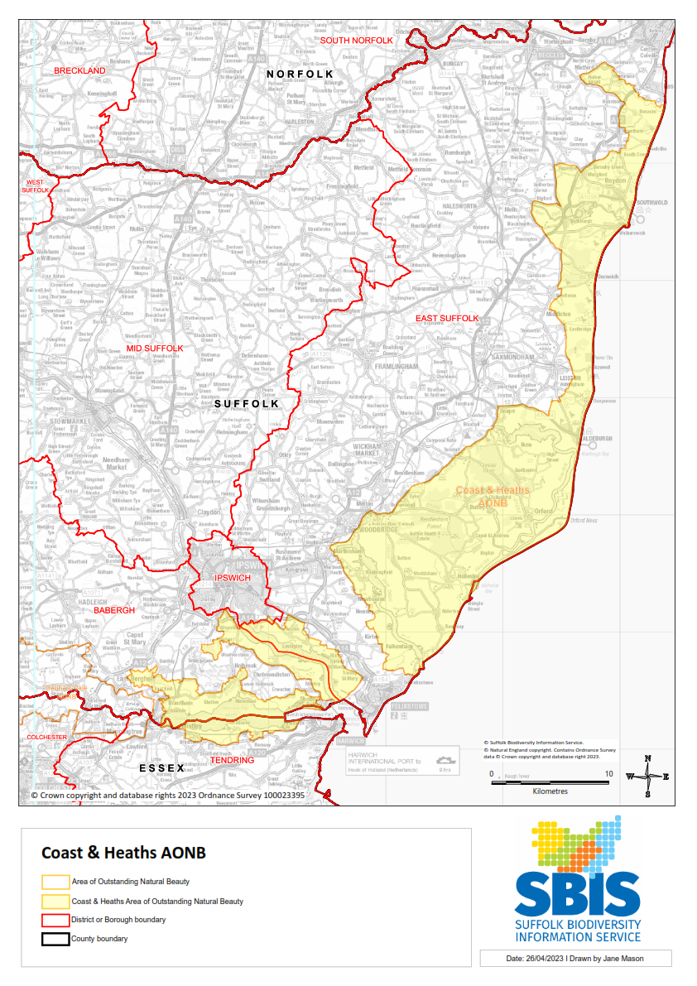

Figure 182: Nature Recovery Core Zone A: Pakefield to Easton Bavents

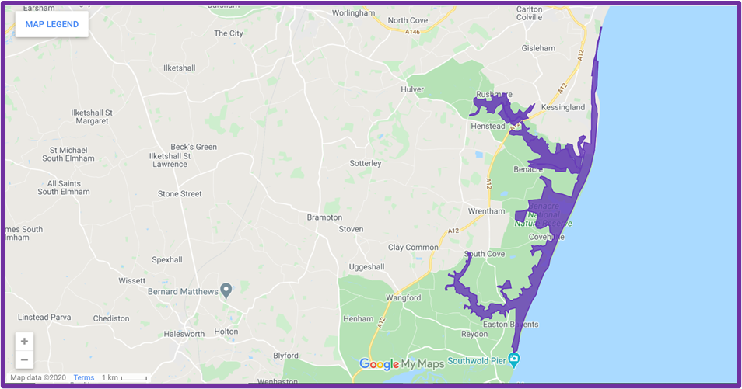

Figure 184: Nature Recovery Core Zone B: Minsmere to Walberswick Heaths and Marshes

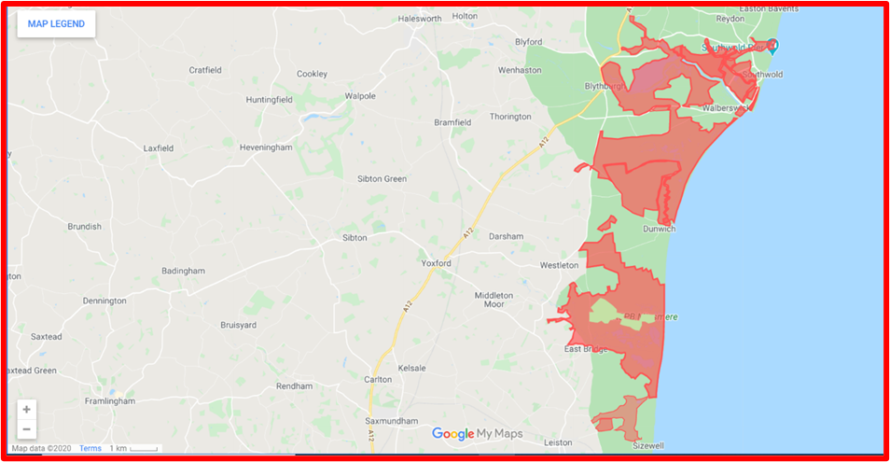

Figure 186: Nature Recovery Core Zone C: Leiston to Aldeburgh

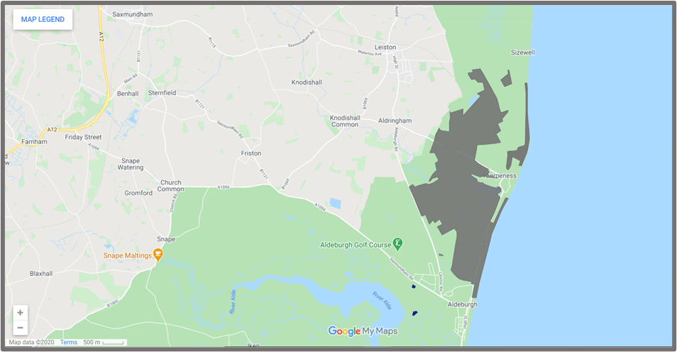

Figure 188: Nature Recovery Core Zone D: Alde – Ore Estuary

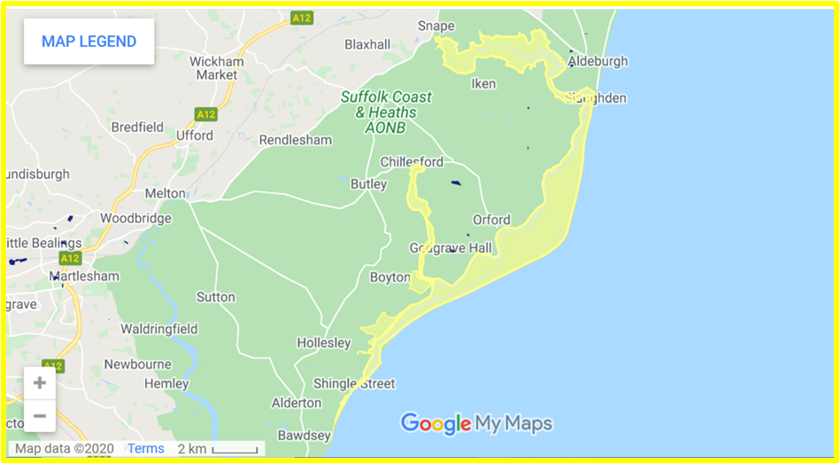

Figure 190: Nature Recovery Core Zone E: Sandlings Forest and Surrounding Areas

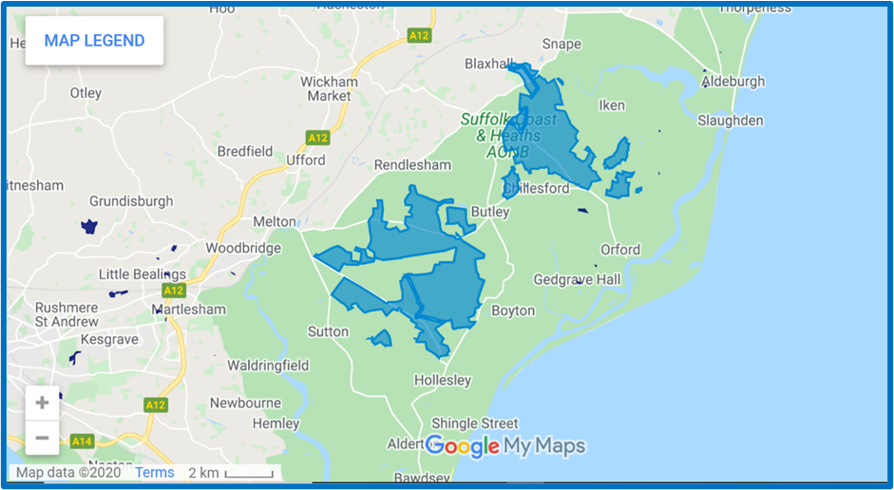

Figure 192: Nature Recovery Core Zone F: Deben Estuary and Surrounding Areas

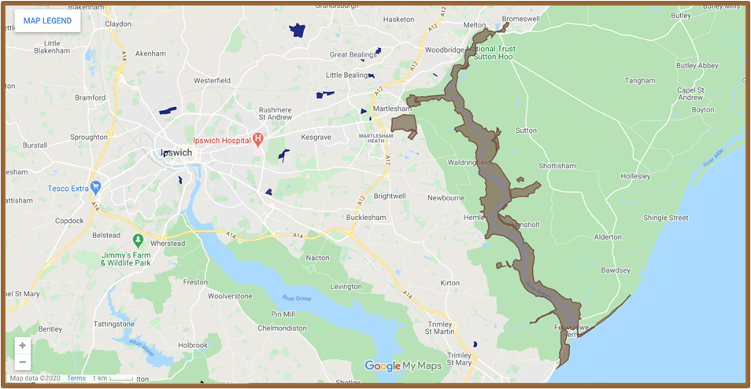

Figure 194: Nature Recovery Core Zone G: Stour & Orwell Estuaries and Surrounding Areas

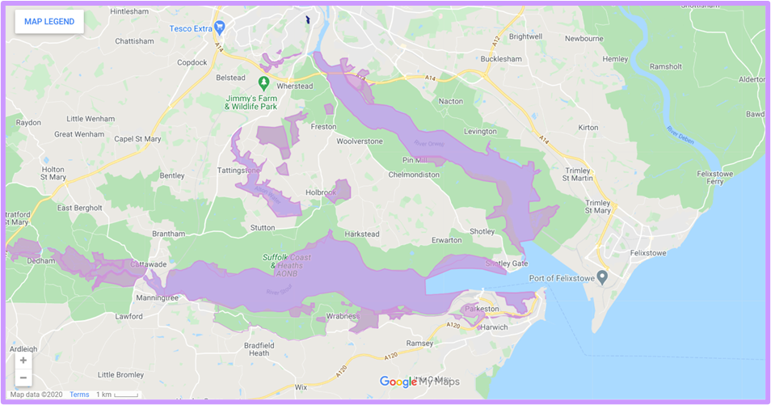

Data

Monitoring

Nationally Significant Infrastructure Projects

**Appendix XX**

**Maps**

**Appendix XX**

**Data**

**Appendix XX**

**Monitoring**

**Appendix XX**

**Nationally Significant Infrastructure Projects impacting the AONB:**

The AONB is subject to several proposals and planning approvals for Nationally Significant Infrastructure Projects that will have an impact on the AONB

As of November 2022, these proposals included:

* Sizewell C (New nuclear) Development Consent achieved
* East Anglia ONE (Offshore wind) Operational
* East Anglia ONE North (Offshore wind) Development Consent achieved
* East Anglia TWO (Offshore wind) Development Consent achieved
* East Anglia THREE (Offshore wind) Development Consent achieved
* Greater Gabbard (Offshore wind) Operational
* Galloper (Offshore wind) Operational
* Five Estuaries (Offshore wind) Proposed
* North Falls (Offshore wind) Proposed
* SeaLink (Electricity connection) Proposed
* Nautilus (Electricity connection) Proposed
* LionLink (Electricity connection) Proposed

These projects will have a variety of impacts on the AONB. Impacts will be felt across all of the designating qualities: Landscape quality, Scenic quality, Relative wildness, Relative tranquillity, Natural heritage features and Cultural heritage.

The impacts will occur during the construction, operation and decommissioning phases of the projects. Construction periods vary from 2 to 3 years for offshore wind farms to 9 to 12 years for Sizewell C. Operation periods range from up to 25 years for offshore wind farms to up to 60 years for Sizewell C. Time taken to decommission offshore wind farms is likely to be a few years whereas the Sizewell C site will take around 20 years to return to a green field site.

Proposers of schemes currently proposed, consented, in construction phase or operational have acknowledged impacts on the nationally designated AONB. National Policy Statements, Local Plans, Policy and Guidance seek to ensure that impacts on the AONB are avoided, minimised, mitigated for and compensated for.

The AONB Partnership provide advice on how to reduce negative impacts on the AONB by engaging in consultation and planning processes. The Partnership is well placed to advise on the best use of any compensation and mitigation funds provided to offset impacts on the AONB.